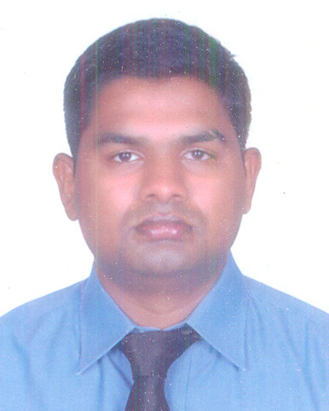
CURRICULUM VITAE

PRADEEP.K.GOWDA
No.49, SOS Post,
Opp, Meenakshi Temple Road
Hulimavu B.G Road Mob: 9620916455
Bangalore – 560076 E-mail: pggod1989@gmail.com

OBJECTIVE :
My career objective is to become a part of a dynamic, growth oriented organization where performance is rewarded and have exposure to a competitive environment and challenging responsibilities.

Professional Snap shot
- Worked at ITC Royal Gardenia Bangalore (As part of the ITC Welcome Group) Laundry Valet for a period of 2 years.
- Worked at Novotel & Ibis tech park Bangalore as Laundry Valet for a
Period of 2.1 years.
- Worked at The Ritz-Carlton Bangalore as Laundry senior 1.9years
- Presently working in band box Karnataka largest laundry as team leader

Job Profile

- Laundry Administration
- Preparing Daily Production Report
- Monthly Production Report
- Daily Chemical Consumption Report
- All Types of Fabric Washing and Dry Cleaning Programs
- Basic Knowledge of All Functions and Modern Laundry Computerized Equipment’s in Five Star Hospitality
- Developing laundry operational procedures & manual
Key Responsibilities
- Supervises laundry and dry clean, to ensure that highest possible hygiene and finish standard of Hotel linen is maintained at all times
- Inspects guest laundry, dry cleaning and press work on a daily basis, to ensure optimum quality of Work, prompt pickup and on time delivery of garments.
- Co-ordinates with Executive Housekeeper and Food & Beverage Manager to ensure that there is an Adequate supply of linen and uniforms available at all time, in particular on weekends/holidays,
- Monitors wash formulas and use of washroom chemicals in order to maintain Whiteness/Brightness.
- Of linen and to ensue linen is returned to user departments free of stains and unpleasant odors’
- Develop and implements standard operating procedures, as well as production and quality standards. Checks constantly all laundry and dry cleaning equipment, to ensure that machines are kept clean, Utilization of water and energy.
- Pleasing personality with the capability of arrangements and execution of the successful parties.
- In-knowledge of different laundry machines
- Comprehensive understanding to diagnose problems with machinery
- Good understanding to maintain stock and invoices
- Good knowledge of standard software that is used to record information pertaining to laundry services
- Working knowledge cleaning practices entail and any related chemical usage
- Good understanding of wash cycle work
- Trained to ensure that all machinery is cleaned and dried before the end of the day
EDUCATION QUALIFICATIONS:

COURSE | INSTITUTION | Year
SSLC | S.S.V Padmanabhanagar | 2004
PUC | National College, Basavanagudi | 2007
B.A. | Vijaya Evening College, Jayanagar | 2011

COMPUTER SKILLS:

- Computer Basic.
- Windows.
- Internet Usage.

Skills & Abilities
- Knowledge of working in laundry appliances, suitable detergents for washing and dry cleaning chemicals.
- Honest, dependable, responsible, cheerful and hardworking.
- Excellent oral communication skills in English, Kannada and hindi.
- Planning and review the organization work and coordinate within the department of the hotel.
- Able to handle the situations and queries of the department and guest.
- Strong ability to handle the staff and work pressure and solve Problem of the staff.
- Handling work pressure in high stress atmosphere.
- Ability to lead, guide and motivate people at all levels.
- Ability to work long shifts and on a seven day roster

STRENGTHS:

- Good Listener and Fast Learner
- Hard Working
- Good Team Member

PERSONAL :

Guardian Name : Mr. Krishna
Gender : Male
Date of Birth : 29.10.1989
Languages Known : English, Kannada & Hindi
Marital Status : Single
Nationality : Indian
Religion : Hindu
Passport No : L7568288

DECLARATION :

I do hereby furnish that the above given information is true and correct to the best of my knowledge.
Thanking you, yours faithfully,
Date:
Place: Bangalore (PRADEEP GOWDA)

