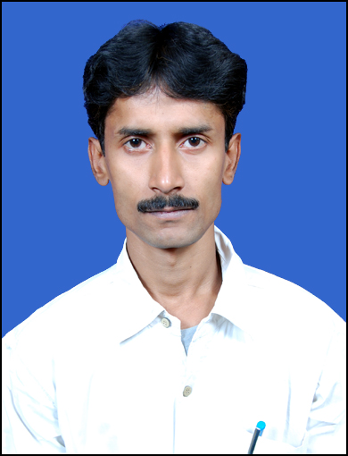

SHASHANK SHEKHAR
Address:
Shashank Shekhar Jha
C/o. - Anand Printek
Near Kenduadih Durga Mandir,
Jharia Road, Kendua, Dhanbad
Pin - 828116
Mobile No: +91-8961480377, 9905540900
Email – shekhar.06400@rediffmail.com, gmail.com

Career Objective

To work for an organization where in meritocracy and hard work is recognized. To undertake tasks, which are not, only challenging but also provide me with learning leading to continuous up gradation of me as a professional.

Work Experience

- Currently Working : Rave Cyber Solution Pvt. Ltd., posted at Dhanbad from 16 November 2016 as a Network Admin in e-governance project at Dhanbad Municipal Corporation.
- Javi System India Pvt. Ltd., posted at Dhanbad from 11 Novermber 2014 to 15 November 2016 as a Network Engineer.
- SYSNET Global Technologies Pvt Ltd, posted at DRM office Alipurduar from 13 March 2011 to 8 September 2014 month working as a Network Support Engineer.
- Bharat Sanchar Nigam Limited formerly known as BSNL recruited at Dhanbad and I was working at Loyabad-Katras Subdivision, worked as a Private Service Engineer in Broadband Subs Management. Total work experience at BSNL is more than 2 yrs.
- SPARX Computers, Dhanbad worked as Service Engineer for 4 yrs.

Computer Proficiency

Operating Systems : Windows 2003/2000 Server, Windows 98, XP, Vista, DOS 6.22, Red Hat Linux 8.
Maintenances : PC all IBM compatible from XT to P-4 & SERVERS ( IBM Series, HP Proliant DL385,
Dell, Compaq ).
Repairs & Configure of : Printers(DMP,Deskjet,Laserjet,LMP(Printronics), Plotter(HP Designjet T610),
Monitors(Basic label),CD Room/Write,FDD,DAT Drives, Configuration of Modems,
(Leased line/ Dialup) Switches, Routers etc.
Configuration
& maintenance of : Installation and maintenance of WINDOWS 2003 Servers, configuration of RAID 1, Network Teaming, Creation of Public and Private network with assignment of

IP addresses, Network load balancing on application server, NTP configuration at local Server and time synchronization to all clients, SNMP configuration at all
systems at customer side like CRIS.
: Installation of HP Storage EVA4100 with host naming creation and LUN creation
with required space allotment through EVA command View EVA Suit software.

: Installation and maintenance of many different application software like COA
(Control office Automation software used at CRIS-Project) like many others
applications software.

: Installation and configuration of Nortel Layer 2 ( NORTEL 325-24T ) and
Layer 3 ( NORTEL5510-24T ) with creation of Virtual LAN.

: Having knowledge and experience of local users group / Active Directory Users,
configuration of DNS Servers, imposing of Group policies, DHCP Servers in windows 2000 and 2003 platforms.

: Remote Access Services and configuration of Virtual Private Network(VPN).

: Configuration of Backup and Recovery Strategies by using DAT drive
(Compaq DAT drive DDS-4/8 GB model C1533A, DDS-3 12/24 GB model
1537A ) using Customers like CBI, UBI etc.

Professional/Technical Qualification
- Diploma in Software Management from G. R. Institute.
- Global Certification CCNA – CSCO11826516

Educational Background

- Graduation (B.Sc.) from R. S. P. College, Jharia, under Vinoba Bhave University with 2nd Div. in 2004
- Higher Secondary(10+2 Std) from R. S. P. College, Jharia under Bihar Intermediate Education Council with 2nd Div. in 2000.
- Madhyamik Exam(10th Std) from Rajkiyekrit Nawsthapit High School, Gaya under Bihar School
- Examination Board with 2nd Div. in 1995

Present Job Profile

Presently working in e - governance project, posted at Dhanbad in office Dhanbad Municipal Corporation, Dhanbad, Jharkhand. In the Headquarter of Municipal Corporation.

Handling Network Devices, Making Local Area Connection, Configuring manageable switches or routers.

Previous Supporting Customers of BSNL & SPARX Computers

- e-governance – Rave Cyber Solutions India Pvt. Ltd. Provides supports for e-governance project software module handling through network devices.
- Bank of India – Javi System India Pvt. Ltd. Provides supports for Cisco IP Phones trouble shoot in Bank of India.

- Alipurduar DRM Office – Providing Service for Network Connection to Server.

- Loyabad & Katras Subdivision – Installation of BSNL Broadband ADSL Routers & Customer Support.

- SPARX Computers – PC Assembling & Customer Service & Residence Support.

Strengths
- Dedication and working desires till the targets are achieved
- Accepting any challenge with positive attitude
- Maintain good inter personal relationship
- Keen desire to learn new concepts and techniques.
- Creative and inclination to innovative works.
- Leadership skills and able to work in teams.

Personal Details

- Permanent Address : C/o. Sri Gyan Prakash Jha, Anand Printek, Near Kenduadih High School, Jharia Road, Kendua, Dhanbad – 828116 ( Jharkhand )
- Gender : Male
- Nationality : Indian
- Religion : Hindu
- Languages Known : English & Hindi.

Declaration:

I do hereby declare that all the information mentioned above is true to the best of my knowledge and belief.
Date : Yours Truly
Place : Alipurduar

Shashank Shekhar Jha

