Curriculum Vitae
` 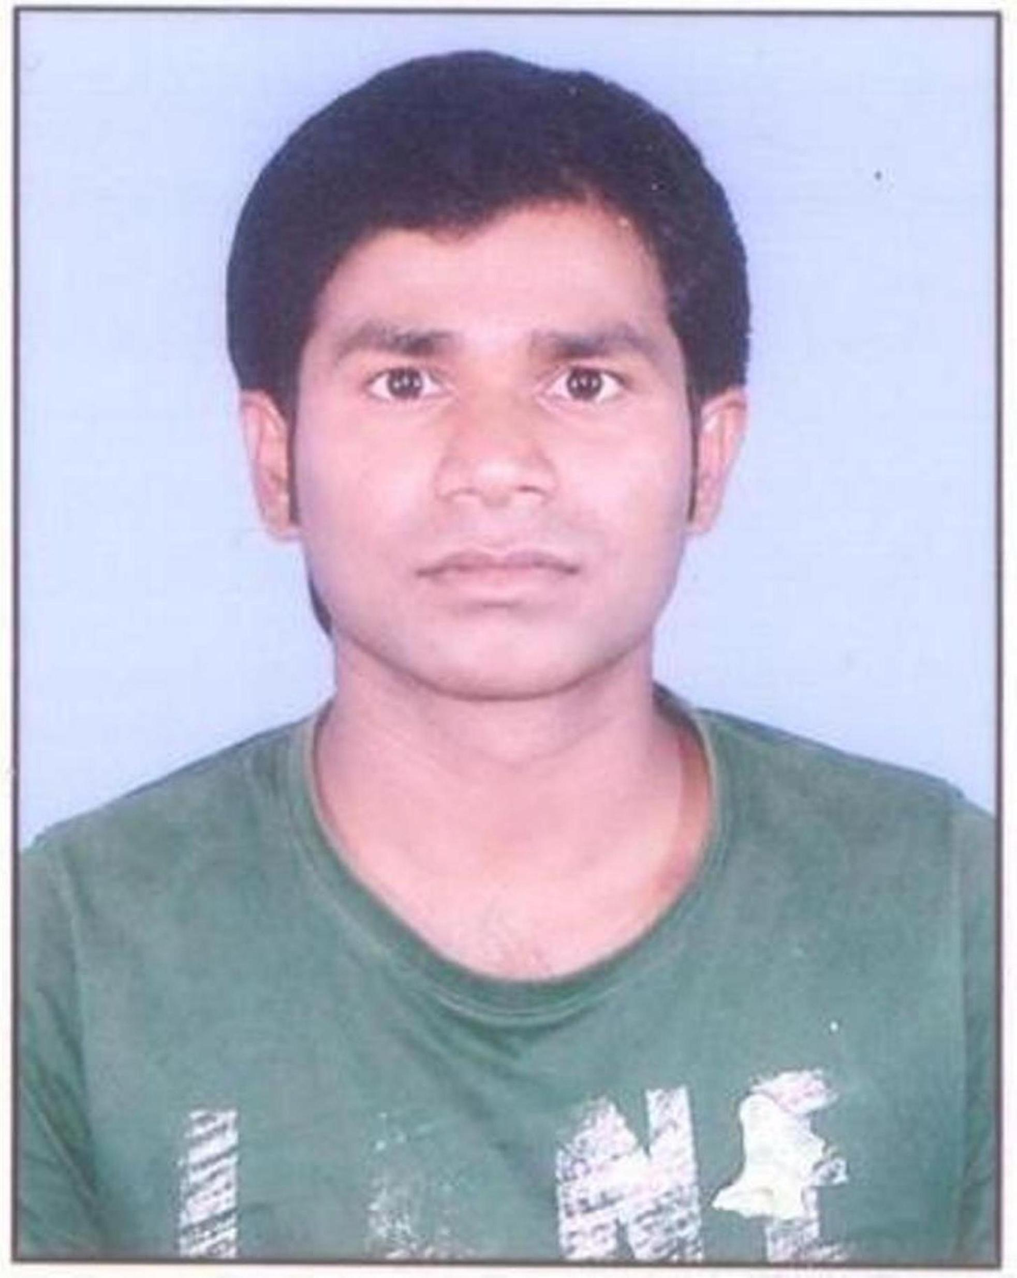

D URYODHAN KUMAR MAHATO
 Email : kumar.duryodhan@gmail.com C/o: lakhan mahato
 Mobile no.: 8409902231 jorapokhar basti ,po-jamadoba dhanbad ,Jharkhand- 828112

CAREER OBJECTIVE

To secure a technical position in an organization where I can effectively contribute my skills as a technical professional and improving innovative idea, possessing technical knowledge.

WORK EXPERIENCE DETAILS
Company : HCL INFOSYSTEMS LTD.
From 2 January 2015 to till date.
Role Associate
Responsibility:
- Data Analysis of UIDAI (Aadhar) resident
- Assist in meetings and provide proper training to new support staff
- Discussed team member about the AADHAR resident rejected or selected.
- Attending the VC monthly and discussed the query with project team member.
Report to project Manager through MIS.

TECHNICAL SKILLS
- Basic computer knowledge
EDUCATIONAL QUALIFICATION

Board/ University | Institution | Passing Year | Examination | Percentage
S.M.U | SIKKIM MANIPAL UNIVERSITY | 2012 | B.B.A | 57.35%
NCVT | GOVT ITI GENERAL Hehal Ranchi, Jharkhand | 2013 | ITI ( Instrument Mechanic) | 81.00%
CBSE | D.A.V Baniahir, Dhanbad, Jharkhand | 2009 | 12th (Commerce) | 46.00%
JAC | MHS Sindri, Dhanbad, Jharkhand | 2007 | Matriculation | 52.8%

EXTRA-CURRICULAR ACTIVITIES AND HOBBIES

- Participated in Hindi song competition during school hour .
- Net Surfing, internal decoration

PERSONAL SKILLS AND DETAILS
Believe on my potentiality, faith on honesty, willingness to learn new things and take challenges beyond my capabilities, interpersonal communications, ability to work collaboratively and commitment to achieving goals are my values

Date of Birth : 14th july. 1991
Sex : Male Nationality : Indian
Father : Lakhan mahato
Mother : Charu devi
Marital Status : Unmarried
Languages Known : Hindi, English
Permanent Address : Dist- dhanbad, Jharkhand

STRENGTH

- Making healthy relation around the people.
- I like my work.
- Self Motivated with a Positive Attitude.
- The ability to work in team.
- Responsible and dedicated to work

DECLARATION
I do solemnly affirm that the above information given by me is true to the best of my knowledge and belief.

Place:
S i g n a t u r e
Date:

