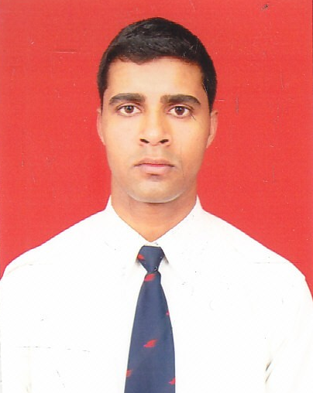
Chandan kumar singh
Misirpur Rohaniya ,Varanasi
Email id :- htmedia.chandan@gmail.com
Contact no :-09871318489,9807145245

Objective
- To obtain a challenging profile in an esteemed organization where I can use my skills
and resource in best possible way

Education qualification.
- B.com from purvanchal university in 2010
- 12th from S.P.I.C inter college in 2007
- 10th from S.S.S. inter college in 2005

Professional qualification
- I have done a professional diploma in airport management in customer care services from Avalon Aviation Academy .
- I have done CCC[by doeacc society]
Experience
- I am working with htmedia.hindustan times as academic counselor ...
Major Strengths :
- Positive attitude
- Keen learner with ability to learn & imbibe new knowledge with ease.

- Good team worker & facilitator.

.

Interest:
- Listening music
- Travelling

Language known
- Engilsh
- Hindi

Personal information

Name : Chandan kumar singh
Father name : Mr. Pramod singh
Date of birth : 05th August 1991
Gender : Male
Nationality : Indian
Marital status : single
Height : 186 cm

Declaratin :-
I here by declare that all information give above are authentic .

Date:

Place : Chandan kumar singh

