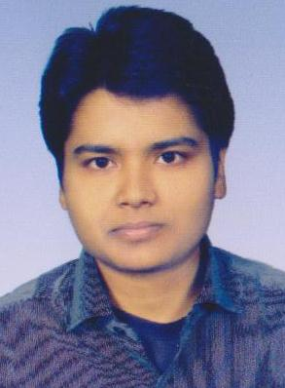
SHRITA KUMARI

H.NO: 91, Matri Bhawan,
North Office Para, Doranda,
Ranchi-834002
Mobile: (+91)9006946313/8051406332
Email: shrita88@gmail.com

Respected Sir/Ma’am

My resume is enclosed for your review and consideration. To describe myself in a nutshell, I am hardworking; ready to take up any challenge of life abreast with the latest trends and a team player with good communication skills.

Review of my credentials will indicate that I am a Qualified Graduate with Arts Discipline from VBU Hazaribagh, have done my Intermediate (I.Sc.) from VBU, Hazaribagh. Apart from that I have knowledge in Computers & Administration.

I am seeking a challenging job that would synergize my skills and knowledge with the objectives of the organization. Being a dedicated and focused individual, I am determined to add value to the organization I work for, through my exceptional knowledge and learning ability.

I am confident that you would find my strong initiatives and commitments to excellence coupled with demonstrated experience and exposure ideal for the position. I mainly focused to do a job in Administration/Clerical/Back Office works.

Waiting for your positive response.

Thanking you for your consideration and forthcoming response.

Yours Sincerely,

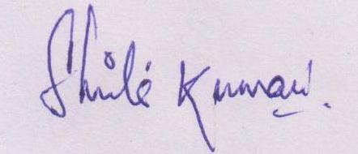

Shrita Kumari

Shrita Kumari
Address- H.No: 91, Matri Bhawan, North Office Para, Doranda, Ranchi
Contact: +91-9006946313, 8051406332; Email: shrita88@gmail.com
CAREER OBJECTIVE :

Seeking a challenging and rewarding opportunity with an organization of repute which recognizes and utilizes my true potential while nurturing my analytical and technical skills.

SUMMARY OF SKILLS:

- Sincere & Qualified with experience of over Eight years in the Educational & IT Background.
- A Systematic, Organized, Hardworking, Focused and Dedicated individual, conceptually Strong with an Innovative and Analytical & Systematic Approach to the work with an eye for detail, determined to be a part of a growth-oriented organization.

PROFESSIONAL SNAPSHOTS:

Professional Qualification | Typing 84 words/min  Completed DCA with 1st class grade from NICE  Completed DCP with 1st class grade from NICE  Completed Tally with 1st class grade from WEBZONE.
Software Proficiency | C, C++, MS OFFICE, Internet
Experience | - Presently working with Jharkhand Rai University, Ranchi as Educational Development Executive in Research Deptt from 27-02-2014 to till date.  - Worked at Balaji Infotech as Accountant /Supervisor for 2 years.  - Worked as office assistant at MAXRIDER, Ranchi for 6 months.  - Worked as Office Assistant/typist/Computer faculty at Accent Tutorial, Ramgarh for 4 years.

EDUCATIONAL CREDENTIALS:

- Master of Business Administration (Pursuing)
Sikkim Manipal University (SMU), Ranchi
- Bachelor in Arts (Economics Hons.) 2011
Jubilee College, Bhurkunda, Ramgarh - 53%
- Intermediate (Science), 2006
Jubilee College, Bhurkunda, Ramgarh - 54 %
- Matriculation, 2004
GHS, Bhurkunda, Ramgarh; 49%
- Date of Birth : 15th of June 1988
- Permanent Address : New Cheep House, Budh Bazar, River Side, Bhurkunda, Ramgarh
Jharkhand – 835129
- Marital Status : Single
- Hobbies : Listening to songs, riding bike, reading & Net surfing

------------------------------------------------------------------------------------------------------------------------------------

