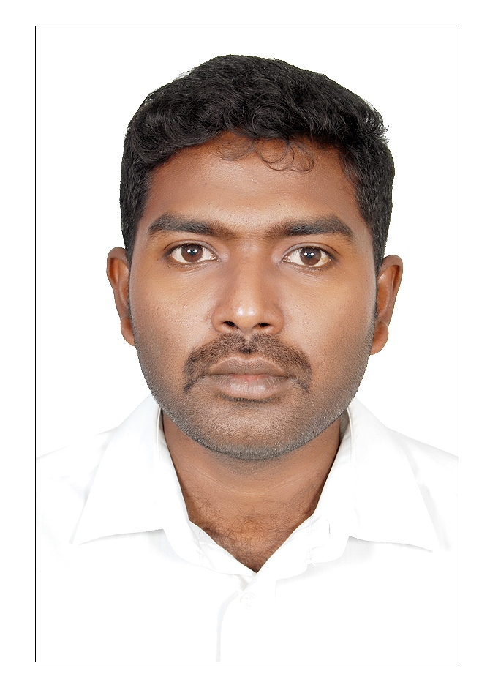 | Post Applied for API Inspector
 | Name: JEBAKUMAR DHARMADOSS
 | Address: | No: 45, K K Salai, MGR Nagar, Chennai,
 |  | Tamilnadu – 600078, India.
 |  | E-mail: jebakumard87@gmail.com
 |  | Mobile: 0091-988 4727 577 (India)
 |  | Alternate : 00966-569439780 (KSA)
Objective:
To develop professionally in the field of Inspection by exploring my knowledge and
Skill, by hard and sincere work attitude acquiring additional qualifications and knowledge.
Educational Qualification:
BE - Mechanical Engineering (First class) from Anna University

Professional Qualification:

- Certified as API 570 - Piping Inspector (Certificate NO: 55659).
- Certified as API 510 – Pressure Vessel Inspector (Certificate NO: 57267).
- Certified as TWI CSWIP 3.1 - Welding Inspector (Certificate NO: 72799).
- Certified as IRCA QMS Internal Auditor, ISO 9001: 2008 (Certificate NO: 11/4457).
- Certified as ASNT Level II in Visual testing (VT), Ultrasonic Testing (UT), Radiography Testing (RT), Penetrant Testing (PT) and Magnetic particle Testing (MT).

Experience Summary:

- For the past 5 years’ Experience gained as Plant Inspector, Welding Inspector, QA/QC Inspector and NDT Inspector by working in various reputed concerns in India and Saudi Arabia.
- The areas of work experience involve In-service, Shut down, Project Execution, Welding WQT and PQR coupon witnessing, Mechanical Testing.
- Exposure in various Non-destructive tests such as UT, MT, PT and RT for Pressure Vessels, Exchangers and Tanks. Thermography surveillance for Reformers, Heaters and piping.
- The various codes used and well versed are ASME, AWS, and API.
- Knowledge in preparing and reviewing of QAP, ITP, WPS, PQR and WPQ documents.
Employment History:
Present and Ongoing Assignment:
Client | : | SIPCHEM Petrochemical Company - Jubail
Assignment | : | CML assessment for equipment’s and piping after field verification for the RBI listed equipment’s. TML marking in the drawings, preparation of corrosion circuits based on the CML markings and summary of requirements based on CML requirements for budgetary purpose.
Duration | : | Ongoing

Past Experience:

- Company | : | NDT Corrosion Control Services Co. - Saudi Arabia
- Client | : | MA'ADEN Phosphate Company - Ras Al Khair
Designation | : | In-service Plant Inspector
Duration |  | December - 2014 to May – 2015.
- Clients | : | ARCC, AYTB, CCC, EVERSENDAI, GSCC, GUSAT, HANBO, L & T - SADARA, NSH, SAMSUNG ENG, SINOPEC, SUNGDO ARABIA, TEKFEN, TCC, S K ENG, S A KENTZ etc.
Designation | : | Third party Welding Inspector
Duration | : | January - 2013 to December - 2014
- Client | : | NDT &CCS
Designation | : | Mechanical Testing Lab inspection Engineer
Duration | : | September - 2011 to December - 2012
- Company | : | Avasarala Technologies Limited - Bangalore
Client | : | Nuclear Power Corporation of India Limited (NPCIL) - Kalpakkam
Designation | : | QA/QC Engineer
Duration | : | July - 2010 to September - 2011
Project | : | Power Reactor Fuel Reprocessing (PREFRE 3 A).

Shutdown Experience

Company | : | NDT Corrosion Control Services Co. - Saudi Arabia
Client | : | MA'ADEN Phosphate Company - Ras Al Khair
Duration | : | January - 2015 to February - 2015 (35 Days)
Designation | : | Plant Inspector
Client | : | SIPCHEM Petrochemical Company - Jubail
Duration | : | September - 2014 (30 Days) and May to June -2015
Designation | : | QC Inspector
Client | : | MA'ADEN Phosphate Company - Ras Al Khair
Duration | : | February - 2014 (15 Days)
Designation | : | Welding Inspector
Client | : | Saudi Aramco Shell Refinery Company (SASREF) - Jubail
Duration | : | October - 2013 to December - 2013 (90 Days)
Designation | : | Welding Inspector
Client | : | MA'ADEN Phosphate Company - Ras Al Khair
Duration | : | April - 2013 to May - 2013 (45 Days)
Designation | : | Welding Inspector

Duties & Responsibilities Carried out:

- Conducted various type of inspections during In-service in compliance with codes, standards and Client approved procedures following the inspection plans.
- Preparation of corrosion monitoring (CML) drawings selecting of CML points for Equipments and ISO for piping circuits after the verification of corrosion conditions. Preparation of scaffold and insulation requirements for budgetary purpose based on site inspection. Participated as a member in RBI assessment team for various clients.
- Performed internal, on-stream and external inspections of equipment’s and piping as per code, Client specification and approved Inspection Test Plan, preparation of reports and recommendations based on the inspection outcome.
- Assessment of damage mechanism and degree of damage, recommending suitable NDT methods to be used and repair recommendations / methodology based on the finding.
- Preparing and executing Inspection Test Plans (ITP), Quality control Procedure (QCP) based on design criteria, in-service condition, and past inspection history. Preparing punch list for completed projects, walk- in inspections before de-blinding.
- Well versed in corrosion rate determination and determining retirement age and inspection intervals. Failure analysis and root cause analysis carried out for Seawater lines.
- Pre shutdown preparations for inspection activities, assessment of inspection manpower and consumables.
- Performed visual inspection of equipment’s, welding inspection, follow up and supervision of repair, modification and replacement recommendation. Interpretation of radiographs for acceptance.
- Performed Thermography survey for identify tube skin temperature of furnace tubes and hot spots of insulated lines and preparing the reports.
- Witnessing of Hydro and pneumatic tests, as per code requirements for the new and repaired equipment’s and piping. Witnessing and verification of Bolt torqueing.
- Inspection and calibration witnessing of PSV and Control valve maintenance and testing.
- Witnessing of Welder qualification test (WQT), Procedure Qualification Record Coupon (PQR) and related mechanical testing, review of final documents as per code requirements and client’s specifications and approval. Various Projects completed for WQT and PQR are SADARA, SATORP, WASIT PKG (Units 1 to 4), KAPSARC and Yanbu Refinery.
- Review of incoming material test certificates, Inspection of incoming raw material, piping components and review of material certificates for acceptance in the stores and at vendor premises.
- Review of sub-contractors QA/QC documents, quality system and recommend approval before awarding the contract.
- Preparing Reliability final summary documentation based on inspection and repairs carried out in shutdowns and Final Management briefing.
- Participated as a member in various teams of Internal Quality Audit for ISO certification, HSE Audit and Vendor Qualification Evaluation. Participated in various Safety courses conducted by my company and clients programs.

Various Codes and Standards used:

API 510, API 570, API 653, API 571, API 577, API 580, ASME B31.3, ASME Section II, ASME Sec-V, ASME Sec-VIII Div. 1 and ASME Sec- IX.
General:

- Good English knowledge for communication and preparation of inspection documents.
- Knowledge to use various computer based inspection and reporting softwares.

Personal Information:

Date of Birth | : | 29-11-1987
Father’s Name | : | Dharmadoss. S
Marital Status | : | Single
Passport number | : | J0875766
Valid up to | : | 26-08-2020

(D.JEBAKUMAR)

