PROFILE 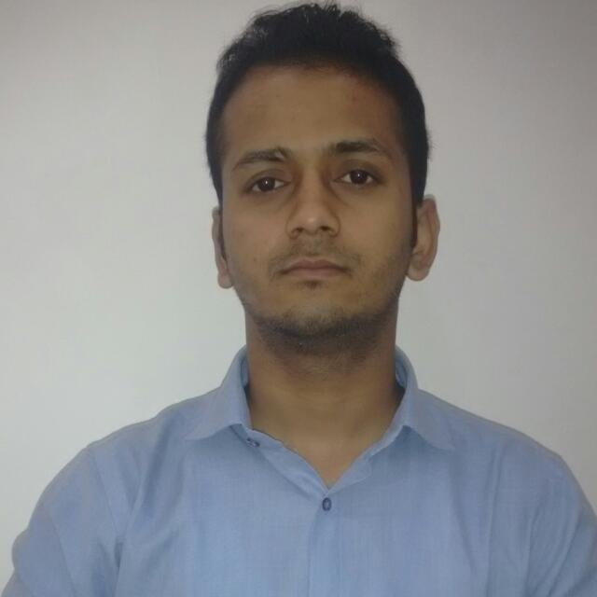
ADRESS: BALAJI BUILDING NEAR DEVLI MOAD , MEHRAULI ROAD KHANPUR,NEW DELHI -110062
Mobile:- 9717595616 ,7053363885
Email:-Surrajsingh93@gmail.com
SURAJ SINGH GOSAI
Objective:
To serve the organization by making optimum utilization of my skills & knowledge and become a professional of excellent repute by effectively contributing towards the goal of Organization.

EDUCATIONAL QUALIFICATION:-

Qualification | Institution | Subjects/Specialization | Percentage | Passing Year
MBA-(PURSUING) | WLCI | MARKETING & SALES | - | 2017
B.COM (Prog.) | DEEN DAYAL UPADHAYA  GORAKHPUR UNIVERSITY | Commerce | 54 | 2014
12th (ICSE) | St. Paul’s School | SCIENCE | 68 | 2011
10th ( ICSE) | St. Paul’s School | SCIENCE | 80 | 2009

WORK EXPERIENCE

NAME OF THE ORGANISATION | DESIGNATION | DURATION
B.R. MOTORS(YAMAHA) | SALES EXECUTIVE | 13 MONTHS

STRENGTH:
- Flexible in understanding new concepts
- Ability to work under pressure
- Effective team player
- Good communication skill
- Can work in MS Office (MS Word, MS PowerPoint, MS Excel)
- Friendly nature

ACHIEVEMENTS
- I received the award for the “Best Basketball player” of the year -2011.
- I served my school as Office Bearer for few years.
- Acted as a coordinator in college fest.
- I was the Marshall(highest rank in an individual house) of my house for two consecutive years
- I got the honour of running with the torch on annual atheletic sports meet twice and was awarded the best athlete for five consecutive years which never happened in the history of my school
- I hold most of the atheletic records to my name in senior most division of my school as well as college
LANGUAGES KNOWN
- Hindi
- English

PERSONAL DETAILS:-
Father’s Name: - Harendra Singh Gosai
Date of Birth:-13th july, 1993

I Suraj Singh Gosai hereby declare that the above provided information is true to the best of my knowledge.

