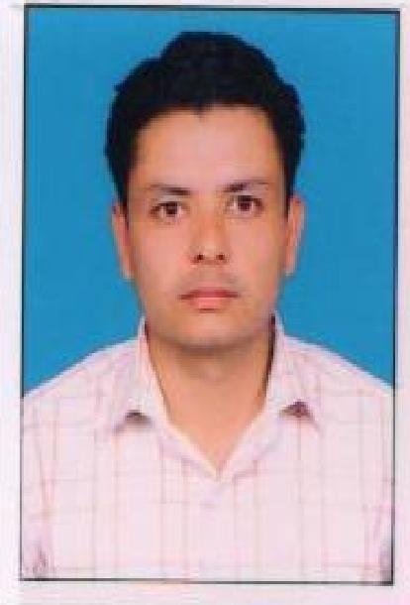
Lalit
Mob: 91-9896469160
Email:lalitsinghbisht44@gmail.com

Address

Objective

Strength

Academic Qualifications

Professional Qualification

Professional Experience

Lalit S/o Dilawar Singh House No. 281/2 Rambir Colony Near Railway Road Jind (Haryana)

Energetic and accomplished professional, Reputation for effective team management, strong organization techniques pay critical attention to detail, and excellent written/oral communication skills in a fast paced environment. Outstanding analytical skills with demonstrated ability to interpret and summarize data into meaningful information. Exceptional multi-tasking capabilities with effective time management techniques.

A quick learner with ability to grasp and express accurately. I am able to monitor workflow, achieve workplace goals with set timeframes, work independently, and maintain accuracy and quality of work output. I believe in developing a healthy, cheerful and friendly environment.

- Graduation from Kurukshetra University Kurukshetra.
- Senior Secondary from Board of School Education, Haryana.
- Matriculation from Board of School Education, Haryana

- M.B.A. from Kurukshetra University in Marketing and HRM

- Dec 2012 to June 2014 in Dencare Remedies as a MEDICAL REPRESENTATIVE.
- July 2014 to Jan 2015 in MANPOWER GROUP SERVICES INDIA PVT. LTD (FULFORD LTD.) at Rohtak (Quadriderm Rf, Dipsalic f, Naturolax,)
- Feb 2015 to till date in THEMIS MEDICARE LTD. At rohtak Headquarter. ( emal , aquadol )

.
