CURRICULUM VITAE
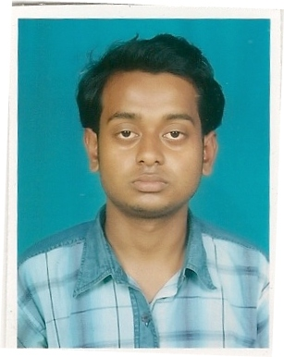
TOTAN KOLEY
C/O –KRIPAMOY KOLEY
VILL- NANDRA
POST+DIST- BURDWAN
PIN – 713101

CONTACT NO:- 9734237753
:-8629920788
Email Id- totankoley1991@gmail.com

Objective
A challenging position in a professional organization where I can enhance my skill, Strength and commitment in a warm and supportive environment in conjunction with the organization goals and objective.

Academic Qualification
- Passed secondary Examination from W.B.B.S.E. (2006) (55.62%)
- Passed Higher secondary Examination from W.B.C.H.S.E. (2008) (55.80%)
- Passed B.A. (General) from Burdwan University. (2011) (37.25%)

Computer Skill

- BASIC, MS WORD, MS EXCEL,
- DIPLOMA IN FINANCIAL ACCOUNTING SYSTEM (F.A.)

Personal Profile
- Fathers Name :Mr. Kripamoy Koley
- Permanent Address :Vill-Nandra, Post+Dist-Burdwan, Pin-713101
- Date of Birth :22th July 1991
- Nationality :Indian
- Religion :Hinduism
- Cast :General
- Sex :Male
- Civil Status :Single

Declaration:
I hereby declare that the above mentioned information is correct to the best of my knowledge and I bear the responsibility for the correctness of the above mentioned particulars.

Date: ………….................. ……………………………….
Place: Burdwan. (Totan Koley)

