SYED SHARIQ ZIA
shariqziajmi@gmail.com,shariqzia438@gmail.com
Cell Number +919990934319, +919548509043
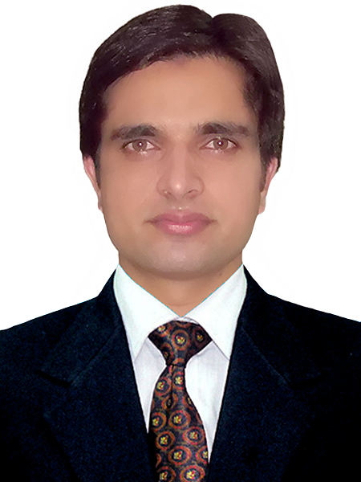
OBJECTIVE: .

To be a part of dynamic and progressive organization, that offers challenging working environment where one can utilize energies and competence in a positive direction and contribute toward overall objectives of organization.

ACADEMIC QUALIFICATION .

B.COM (Bachelor of Commerce) Session 2010-2013
I have compeleted my graduation in 2013
Institute: Jagdish Saran Hindi (PG) College Amroha,
University: Mahatama Jyotiba Phule Rohilkhan University, Bareilly
Division: Second
Percentage: 58% (approx)
Higher Secondary Session 2009-2010
Institute: I.M. Inter College, Amroha.
Division: First
Percentage: 70%
Secondary Session 2007-2008
Institute: I.M. Inter College, Amroha.
Division: Third
Percentage: 45%
WORK EXPERENCE .

Experience:-

3 years experience as Computer Operator-cum Storekeeper in, Jamia Millia Islamia a central university, New Delhi 110025

Duration 01 June 2013 to Till Date

* Through Outsourcing (Contractual Basis)
By Company: K.M.S Enterprises, 80-A Bharat Nagar New Friends colony New Delhi-110025

Duties:-

Type official letter, Notice, Note etc which send to administration department of the university
•I have managed all spots items.
To keep the material on the racks, pallets and almirah as per location wise
•Sending & receiving all spots items with detail.
To issues receive the materials.
To maintain the material stock position according to the requirement of production.
•Prepare the item stock report.
•Maintenance stock register.
All stock are entered in stock register before received and sent
Before received items are verified from Purchase Order.
Give Order before short of the items.
Data entry of in carry/dispatch/updating contracts/bill detail.
Help in the Meeting etc.

COMPUTER SKILLS: .

- Knowledge of Microsoft Word, Microsoft Excel, Power Point, Tally
- Better Knowledge of Internet Surfing
- Have good typing speed (approx) 30 words per Minute.
- Email
- Drafting

Extra Curricular Activities: .

- I am a member of NGO (Non Governmental Organization)

Personal Information:

Father’s Name Mr Javed Ishrat Kazmi
Address 1394 Katrabajwariyan Ballimaran Delhi – 11006
Date of Birth 27 September 1994
Sex Male
Marital Status Single
Nationality Indian
Languages Hindi, English
Hobby Bike riding / Reading/Cricket

Place…………
Date………….. (SYED SHARIQ ZIA)

