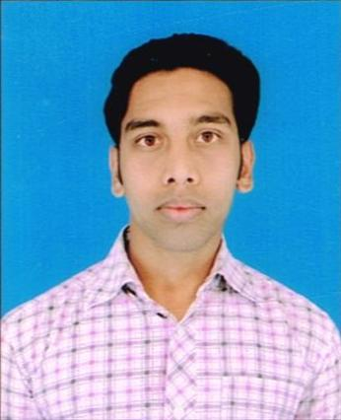
CV
MD Minhaz Alam
Address:
AT+PO  Hosir, PS  Gomia, Distt.- Bokaro, JHARKHAND, 829111
Mob: 8083642473, 8083893624
Email: minhaz520@gmail.com
Father name- Nurul Hoda

Career Objective:

Looking for a promising & challenging career which will enable me to provide best of my Technical, analytical & professional skills. A career which can sharpen my current skills and Knowledge and where I can have a good scope for learning and implementing new technologies.

Academic Qualification:

Degree/ Certificate | Board/ University | School / College | Year of Passing | Percentage
10th | JAC Ranchi | High School Hosir | 2008 | 75.2%

Technical Qualification:

Degree/ Certificate | Board/ University | School / College | Year of Passing | Over All Percentage
Diploma in ECE | SBTE Jharkhand | Govt. Polytechnic Koderma | June, 2013 | 72.27 %
Semester wise details:

Semester | Full Marks | Obtain marks | Percentage
1st | 750 | 544 | 72.53 %
2nd | 750 | 502 | 66.93 %
3rd | 750 | 553 | 73.73 %
4th | 750 | 561 | 74.80 %
5th | 750 | 535 | 71.33 %
6th | 750 | 557 | 74.27 %

Professional Experience:

1. Company: HCL Infosystem Ltd. Patna.
Possition: Technical Support Engineer
Emp. Code: 33004991
Experience: July, 2013 to May 2014.

2. Company: HSB Infotech Pvt. Ltd.
Position: Desktop Support Engg.
Experience: May, 2015 to June, 2015.

3. Company: Wipro Infotech Ltd.
Position: Technical Support Engg.
Emp. Code: 679119
Experience: July, 2015 to continue..

Technical Skills:

1. Assembling of Computer Systems.
2. Installation & Troubleshooting of Software & Hardware Devices.
3. Installation & Troubleshooting of Operating System.
4. Installation, Configuration & Troubleshooting of Printers (DMP, Laser jet).
5. Installation & Troubleshooting of Application Software.
6. Installation & Troubleshooting of Internet & Internet Browsers.
7. Installation & Troubleshooting of Networking devices (LAN).
8. Installation & Troubleshooting of Router and Switch.
9. Hands off Working Knowledge in SAP System.
10. Hands off Working Knowledge in Lotus/Outlook configuration.

Professional Trainings:

- Organization: DVC BTPS, BOKARO
- Project: Vocational Training
- Duration: Four weeks.

Strengths:

- Ability to deal with people.
- Passionate team worker.
- Hardworking & self confident .
- Flexible towards learning new concept.

Personal Information:

Date of Birth: 2nd Jan, 1992
Gender: Male
Nationality: Indian
Religion: Muslim
Marital Status: Single
Languages Known: English and Hindi
Interest: Reading, Listening to Music, Sketching.

Declaration-

I Consider myself familiars with Electronics & Communication Engineering and IT Field aspects. I am also Confident of my ability to work in a team. I hereby declare that the Information furnished above is true to the best of my knowledge.

PLACE-: Ranchi ( MD Minhaz Alam )

