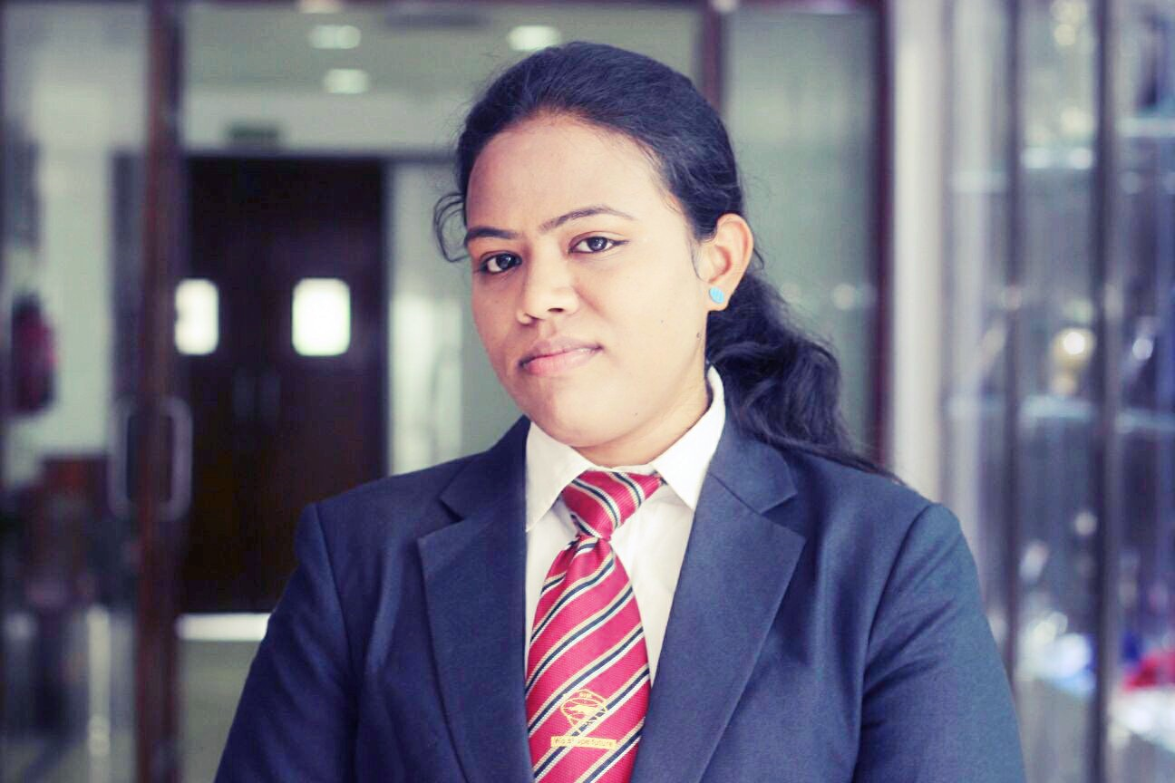

Heena Kausar

Mobile:9650765249 Email:heena.kausar705@gmail.com

CAREER OBJECTIVE

Seeking a career in Human Resource to utilize my knowledge, personal skills to gain comprehensive understanding at a reputed organization so as to take responsibility and contribute significantly.

ACADEMIA

BOARD / UNIVERSITY | EXAMINATION | ACADEMIC YEAR | PERCENTAGE | NAME OF SCHOOL/COLLEGE
AICTE | PGDM | 2014-16 | Pursuing | ASIA-PACIFIC INSTITUTE OF MANAGEMENT, NEW DELHI
RAVENSHAW  UNIVERSITY | BBA | 2010-13 | 62% | RAVENSHAW UNIVERSITY, CUTTACK, ODISHA
I.S.C BOARD | 12TH | 2010 | 51% | ST.JOSEPH’S CONVENT HIGH SCHOOL, MOSABONI
I.C.S.E BOARD | 10TH | 2008 | 67% | ST.JOSEPH’S CONVENT HIGH SCHOOL, MOSABONI

TECHNICAL SKILLS

MS Office applications, Tally ERP, and SPSS (Statistical Package for Social Sciences) Software.

PROJECTS
- Safety and welfare measures for employees (During PGDM)

INTERNSHIP

HINDUSTAN COPPER LIMITED/INDIAN COPPER COMPLEX, Ghatsila, (Jharkhand)
Duration:60Days
Description: Understood different types of work of HR under various departments like Works office, Times office, Safety department and Recruitment & Establishment.

COMPETENCIES SKILLS

- Innovative approach
- Result Oriented
- Ability to initiate
- Presentation & Negotiation skills
- Team Management

PERSONAL DETAILS

Present Address : YWCA women hostel, Pocket-6, Plot-4, Jasola, New Delhi-110025
Permanent Address : QTR. No. A/55/CD, MBR ‘A’ Block, Ghatsila, Jharkhand-832303
Languages :Hindi & English

DECLARATION

I adhere that the information provided in this document is true to the best of my information and belief.

Date: SIGNATURE
(Heena Kausar)

