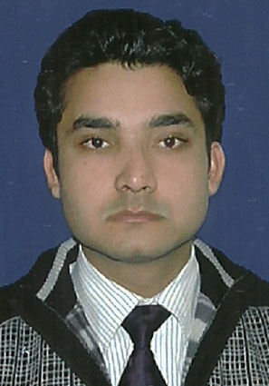
VIKAS SHARMA
Mobile: +91- 9911500555~ E-Mail: vikasksharma07@gmail.com
To be a successful corporate leader by contributing with the best of my knowledge and skills.

PROFESSIONAL ABRIDGEMENT

- A competent professional with nearly 4 Year 07 Month of widespread cross cultural experience in marketing, Client Servicing, acquisition and Liaising with Clint.
- Presently working as S.r Executive in Sales with Gulshan Homz Pvt. Ltd.
- Deft in conducting corporate activities involving understanding and sourcing financial information and acquiring new HNI clients for the company and providing them financial knowledge ensuring good margin and quality clients.
- Possesses good understanding of business and financial products.
- A good communicator with exceptional presentation & problem solving skills & abilities in forging business in markets.
COMPETENCY MATRIX

Client Relationship Management
- Ensuring customer satisfaction by achieving delivery & service quality norms.
- Maintaining cordial relations with customers to sustain the profitability of the business.
- Providing value added customer services by attending customer queries and issues.
- Supervising and monitoring closely customer service operations for rendering and achieving quality
Business.

EMPLOYMENT SCAN

From November,14 to Till date with Gulshan Homz Pvt. Ltd. As S.r. Executive In Sales
Deliverables
- Maintaining cordial relation with clients and channel partners.
- Formulate and conduct training and development programmers’ for the channel partners
- Supervising and monitoring closely customer service operations for rendering and achieving quality Business.
- Providing value added customer services by attending customer queries and issues.
- Ensuring customer satisfaction by achieving delivery & service quality norms.
- Generating business from the clients, thereby achieving sales target for the organization.
- Acquisition of new clients.

From March` 14 to Nov.14 with Paras Buildtech India Pvt. Ltd. as Executive In Sales
Deliverables

- Maintaining cordial relations with customers to sustain the profitability of the business.
- To meet the prospective clients/sub dealers.
- Liaising with Client for timely & quality delivery of services.
- To be a part of Possession Team.
Since May`11 to March 14 with Birla sun life insurance as Executive Unit Sales Manager For Deutsche Bank
Deliverables
- Working with HNI and high profile clients.
- Conduct market survey and corporate activities for gathering knowledge about prospective clients and marketing areas while assessing possibilities of increasing revenue by selling different financial products.
- Evaluating financial products and existing trends in the market while making a survey on competitors and market trends.
- To meet sales target consistently.

Significant Achievements
- Qualify for SANGHAI trip in November 2013 for excellent performance.
- Played pivotal role in handling a wide array of corporate and high net -worth clients.
- Proven track record in achieving set targets throughout stint.
SCHOLASTICS

2011 MBA (Major–Marketing, Minor-Human Resource Management) from Gautambuddha Technical University, Greater Noida.
2009 BBA, Institute of management and research, Ghaziabad.

VOCATIONAL TRAININGS AND PROJECTS UNDERTAKEN

Summer Training
Company : ENTERTAINMENT NETWORK (INDIA) LTD.
Location : New Delhi
Duration : 6 months
Title : Branding and Strategy Management.’
Description: Project entailed detailed study on conducting market research of Media industry while assessing level of awareness among young graduates and working executives.
COMPUTER PROFICIENCY

Packages : MS-Office.
Other Skills : Web Technology

PERSONAL DOSSIER

Date of Birth : 11th December, 1987
Current Address : H-741 Sector 33 Noida.
Languages Known: English and Hind.

Date :
Place: Noida (VIKAS KUMAR SHARMA)

