Curriculum Vitae 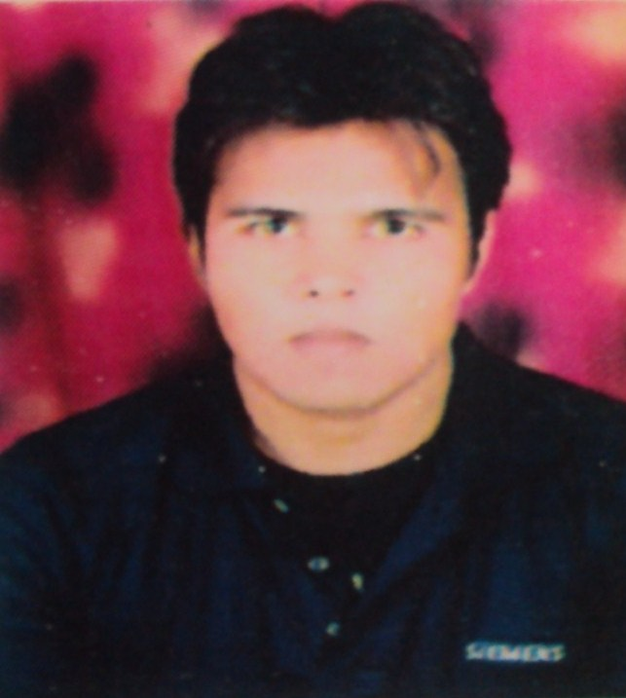

VIKAS KUMAR

MOBILE : +91 9868210578, 9810637798
E-MAIL : kumar.vikas1007@gmail.com / vikas2kr@yahoo.co.in

Objective
OBJECTIVE:

To secure a job of WEB Developer in the field of PHP this can widen my knowledge base and enhance my skills so that I can contribute fully to the growth of the organization. To obtain a position with a progressive web development or software development company with a strong focus on creativity and problem solving. To support a network infrastructure based on multiple operating systems and complex network topologies. To find a position that is challenging, rewarding and provides an opportunity to expand my knowledge and abilities in creating client centric solutions.

Experience

Company Name | Post Held | Experience | Nature of Duties
U. G. Software Technologies Pvt. Limited | Software Developer (CORE PHP, Magento, Opencart, Cake php) | 1.2 Year | Working on Core PHP, Magento, Cake php, Opencart, Wordpress, Joomla

Company Name | Post Held | Experience | Nature of Duties
Spadille Technologies Pvt. Limited | Sen. Software Developer | 8 Months | Working on Core PHP, Magento, Cake php, Opencart, Wordpress, Joomla

Technical Skills

Operating Systems : XP / Windows 7/98
Programming Language : PHP, C, OOPS, MVC
RDBMS : MYSQL
Scripting Languages : HTML, CSS, jQuery
CMS : MVC Structure, WORDPRESS, MAGENTO, OPENCART, CAKE PHP

Additional Technical Skills
:

Programming Language : C# , ASP.NET
Framework : Visual Studio 2008
Web Designing Tool : Adobe Photoshop

Key Responsibilities

Role | Details | Proficiency(out of 10)
HTML & Css | I have designed web pages using html | 6
Core Php | In this I have learnt the basics of php | 7
Manage Database | In this I have created list page and manage the database connectivity and perform all the basic (curd operations) | 7
Magento | we are managing different portions of the website using admin panel, and  Make changes in our website as per requirement( such as adding text fields, storing their content in database and how to show it on the front end using phpmyadmin which is our database) | 7
Opencart | Module Customization and develop website and admin management | 7
Cake Php | MVC structure, development modules. | 8

Project Done

PHP PROJECT: 1 KNOWLEDGE-TT

Title | KNOWLEDGE-TT ( Articles & Blogs website )
Technology | Core PHP
Role | - Developer

PHP PROJECT: 2 Ipal

Title | Ipal (An Interactive learning)
Technology | Magento php (http://www.i-pal.ca/ )
Role | - Development & Customization from backend

PHP PROJECT: 3 Blacktie Wine Shop

Title | Blacktie Wine Shop
Technology | Magento php (http://blacktiewine.net/beta )
Role | - Development & Customization from backend

PHP PROJECT: 4 Vipera Cosmetics

Title | Vipera Cosmetics
Technology | Magento php (http://ugprojects.com/vipera/vipera)
Role | - Development & Customization from backend

PHP PROJECT: 5 Mababer Deals

Title | Mababer Deals
Technology | Magento php (http://ugprojects.com/mabbr/mababer/ )
Role | - Development & Customization from backend

PHP PROJECT: 6 Waterview Homes

Title | Waterview Homes
Technology | Core PHP (http://www.waterviewhomes.co.uk/)
Role | - Development

PHP PROJECT: 7 Mackay Toyota

Title | Mackay Toyota
Technology | Core PHP (http://www.mackaytoyota.com.au/ )
Role | - Development

PHP PROJECT: 8 Mackay Mazda

Title | Mackay Mazda
Technology | Core PHP (http://www.mackaymazda.com.au/ )
Role | - Development

PHP PROJECT: 9 Lakeside Lighting

Title | Lakeside Lighting
Technology | Magento PHP (http://lakesidelighting.ca/ )
Role | - Development

PHP PROJECT: 10 Perisale

Title | Perisale
Technology | Magento PHP (http://www.perisale.com.au/ )
Role | - Development

PHP PROJECT: 11 Little1

Title | Little1
Technology | Core PHP (https://www.little1.in/ )
Role | - Development

PHP PROJECT: 12 BodCabinet

Title | BodCabinet
Technology | OpenCart PHP (http://www.bodescabinets.com/ )
Role | - Development

PHP PROJECT: 13 Austrailan farms Sales

Title | Austrailan farms Sales
Technology | Cake Php (http://www.australianfarmsales.com.au/
Role | - Development

PHP PROJECT: 14 Lawworldconnect

Title | Lawworldconnect
Technology | Cake Php (http://lawworldconnect.com/)
Role | - Development

PHP PROJECT: 15 Genesis IT

Title | Genesis IT
Technology | Opencart (http://ugprojects.com/genesis/v2 )
Role | - Development

Education

- Intermediate (12th) from U.P. Board in 2006 with 1st division.
- High School (10th) from U.P. Board in 2004 with 1st division.
- B-Tech in CS from GBTU University in 2011 with 1st division.

Personal Profile

Sex : Male
Marital Status : Unmarried
Nationality : Indian
Languages : English, Hindi & Punjabi
Date of Birth : 10/07/88
Permanent Address : D-364 Ganesh Nagar, Pandav Nagar Complex, Delhi-1100*92

Strengths

- I consider myself to be very consistent, optimistic, enthusiastic and determined.
- I feel myself to be a quick learner and hard worker and punctual in task.

Declaration

I hereby declare that the above-mentioned information is correct up to my knowledge and I bear the responsibility for the correctness of the above-mentioned particulars.

Date:

Place: DELHI (VIKAS KUMAR)

