RESUME
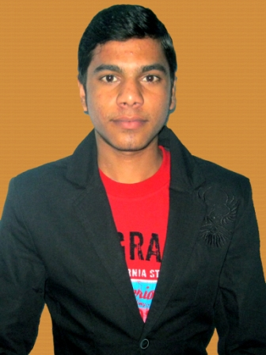
MD NASIR HUSAIN

SIMRI BAKHTIYAR PUR

SAHARSA 852127

BIHAR
Mobile No- 8235548642, 9155526741
Email: - nasirhusainph@gmail.com

Career Objective

To be a part of an Organization can utilize my experience and knowledge in Hardware, Operating System (O.S) as well as successfully any computer Operate & Handle. I like target with continuously growing the organization.

Academic Qualification

- Bachelor of Arts (Graduation) with 69% from B.N.MANDAL UNIVERSITY in year 2016.

- Intermediate Arts with 71% from Bihar School Examination Board in Year 2012.

- Metric with 78.20% Bihar School Examination Board in year 2010.

Technical Qualification

- Jetking certified Hardware & Network Engineer (JCHNE) Diploma course from Jetking Computer Hardware & Networking Institute, Boring Road Patna in year 2014.

- DCA from TARAHAAT centre ,Saharsa in year 2012.

Project
- Successful done a project with team in Jetking lab.
- Installing & Managing different O.S as( win xp,7,win server 2k8)
- Assembling , Disassembling PC
- Troubleshooting hardware & Transmission Media problems
- Working with tool as (crimping tool ,cabling & punching tool)

Computer Skills

Server : Windows® (2008 server)

Client : Windows® (XP, Vista, 7, 8, 10)
Applications : MS Office (2003, 2007, and 2010)
(Word, Excel, PowerPoint, Outlook)
Team Viewer, Internet, Antivirus, Firewall, VMWare etc.

Technical Knowledge

- Assembling of PC’s & Laptops
- Installation & Troubleshooting of Software’s & Hardware Devices
- Installation & Troubleshooting of Operating System & Printers
- Configuration of Domain & Workgroup
- Able to work with MS Office, Photoshop, Pagemaker , etc.
- Working with LAN & Directory

Experience
Organization : Koshi Computer Center
Designation : Basic IT Trainer
Period : January -2016 to till Date

Organization : HDFC BANK
Designation : Desktop Support Field Engineer.
Period : April -2015 to November - 2015

Organization : Arc. Instruments Ltd.
Designation : Service Engineer.
Period : May -2014 to January - 2015

Languages Known

English, Hindi, Urdu, Arabic, Persian.

Personal Details

Father Name : MD ZAHIR ALI
Date of Birth : 07-AUG-1995
Interests : Computer environment, Surfing Net, Reading IT Book, travelling etc.
Interpersonal skills : Systematic and calculated Approach, Adapting to work
environment, Politeness.

Declaration:-

I am, MD NASIR HUSAIN , hereby declare that the above furnished information is authentic to the best of my knowledge.

Date:
Place: Applicant’s Signature

