Neha Garg
Email: singla4801@gmail.com Phone: +91-9958734801
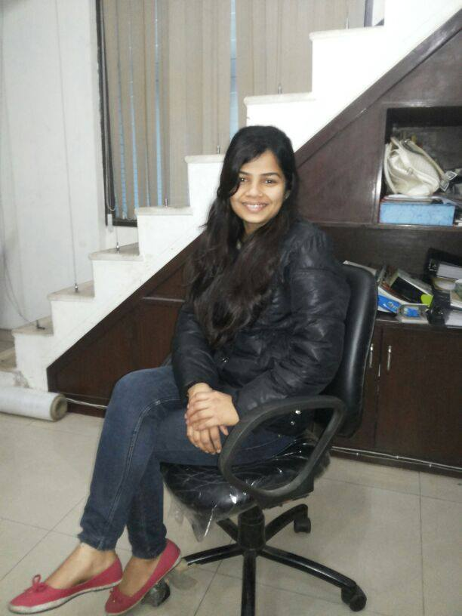

Career Objective | To work in an organization where my skill and talent can be utilized in the best way and give me good learning opportunities.

Current Role Description  Previous Employer  Previous Employer  Previous Employer | M/s. KRM Corporation July 2015 to till date  Product Manager  Key responsibilities:  - Making Quotations (International)  - Maintaining Customer Relations  - Co- ordination with International clients  - Follow Ups for lead conversion  - Formatting presentations  - Administrative work.  - Generating reports  - Preparing Tenders.  - Handling Team  - Giving presentations to new team members and clients related to products.  M/s. SledgeHammer Oil Tools Pvt. Ltd. July 2012 to 7th April 2015  Quotation Executive (Marketing)  Key responsibilities:  - Making Quotations (International, Domestic Both)  - Maintaining Customer Relations  - Co- ordination with International and domestic clients  - Follow Ups for lead conversion  - Formatting documents, reports.  - Administrative work.  - Generating reports  - Scanning, faxing important and confidential documents.  - Handling Incoming/outgoing mails in an office needs to be carried out systematically and efficiently.  - Preparing Tenders.  - Maintain filing systems and updating of records.  - Update computer data  - Maintaining files for Auditing  M/s. Akash Pack Tech Pvt. Ltd. Feb 2012 to July 2012  PA to VP (Vice-President)  Key responsibilities:  - Data entry format in MS-Excel.  - Generating reports.  - Formatting documents, reports.  - Administrative work.  - Prepare power point presentations for the Meetings and Conferences.  - Scanning, faxing important and confidential documents.  - Handling Incoming/outgoing mails in an office needs to be carried out systematically and efficiently.  - Draft and type business letters to vendors thereby dispatching the same.  - Archival of Documents – Personal and Official for the Director.  - Maintain filing systems and updating of records.  - Update computer data  - Makes Invoice bills & Quotation  HDFC Bank, Faridabad Sep 2010 to Feb-2012  Office Coordinator  Key responsibilities:  • Record & handle all incoming & outgoing calls.  • Maintains files and Correspondence..  • Record of all relevant data & Correspondence.  • Co-ordination with all clients.  • Handling client queries related to the product and replying to enquiries  • Dispatch related Queries  • Calling clients and focus on client services  • Maintains receipts & Courier.  • Follow Up to the Clients for the Releasing Payment.

Technology Experience
Software | MS-Office 2003, 2007 (Word, Excel, Power point), Internet & Mailing
Operating Systems | Windows 95/98/XP

Education Summary
Degree and Year | University / Board | Year / Per
MCA | M.D. University | 2013 /78%
BCA | M.D. University | 2010 / 84%
Senior Secondary, | Haryana Board | 2007 / 82%
Higher Secondary, | Haryana Board | 2005 / 76%

Personal Details
Husband’s Name | Mr. Nitin Garg
Date of Birth | Feb 15, 1990
Hobbies | Reading Story & Group Discussion

Major Strengths
- Ability to Focus on Projects
- Ability to work Under Pressure.
- Ability to prioritize.
- Easily adaptable new Environment.
- Positive attitude.
- Leadership Skills

Address
H. No. -6, Street No 2, Adarsh Nagar,
Malerna Road, Near Dhruv Vatika,
City: Ballabgarh, Distt.: Faridabad,
State: Haryana - 121004

Date…………………

Place………………………. Neha Garg

