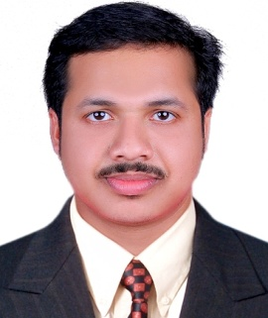
DRatheesh Kumar RS
Document Controller / EDMS Officer.
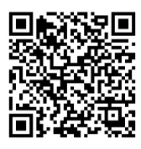
Mobile: +91- 8281 792949 / 89211 42334 (India)

E-mail: Ratheeshkumar_achu@yahoo.com
Ratheeshanchal.2021@gmail.com
Skype: Ratheesh.anchal

Summary

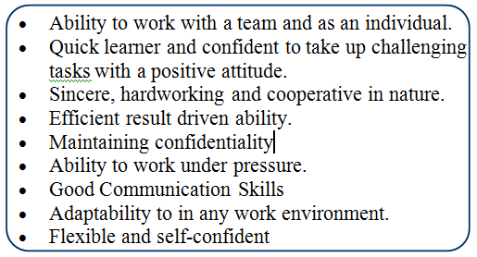

I have more than 13 Years’ work experience in Documentation as Document Controller in the Oil and Gas Companies in Middle East. Extensive experience in EDMS, SPF-Smart Plant Foundation, PetroceptDC, Documentum, E-room, etc. To secure a job position as a document and documentation controller where dedication, hard work and the ability to acquire new skills will benefit the company for which I work.

Qualifications

Master of Business Administration
Bachelor of Arts
Pre-Degree Arts
Technical Qualifications
Diploma in Computer Science
Diploma in Office Automation
Desktop publishing - DTP

Work Experience & Clients
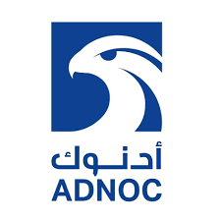


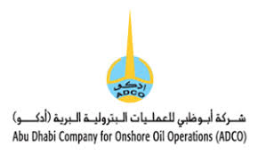


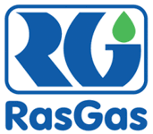
- Petrofac Emirates LLC - (Adnoc & Zadco )
- Petrofac International Ltd - (Turkmengas & Adco)
- Dodsal Engineering & Construction Pvt Ltd -(Takreer & Gasco)
- Dodsal Engineering & Construction Pvt Ltd- (CTJV -RasGas)
IT Skills

- Knowledge in ADNOC SFTP, Access, Digital signature, Adobe Document Cloud, Microsoft Outlook 2011
- MS Windows operating systems
- MS Office applications- Word/Excel/PPT, Microsoft 365.
- Internet & E-mail Applications
- Petrocept DC-EDMS (Petrofac Software for DDC), SPF-Smart Plant Foundation.
Software Training

- Smart Plant Foundation (SPF – EDMS -Software ) – Petrofac International LLC
- Petrocept DC (EDMS - Software) Petrofac International LLC
- Documentum & FTP / eRoom / SFTP (Adnoc) - Petrofac International LLC

Proven Job Roles
- Petrofac Emirates LLC : Document Controller -I (2011 to 2020)
Islands Surface Facilities Project - EPC2 - Zadco Company (UZ750) – Abu Dhabi
South Yoloten Gas Field Development Project – Turkmenistan
- Petrofac International Ltd : Document Controller
Abu Dhabi Company for Onshore Oil Operations (ADCO) – Asab- Abu Dhabi
- Dodsal Engineering & Construction Pte Ltd : Document Controller (2008 to 2010)
Ruwais Sulphur Expansion Project III / GASCO / Ruwais – Abu Dhabi
- Dodsal Engineering & Construction Pte Ltd : Document Controller (2006 to 2008)
Ras Gas Onshore Project RGX II – Chiyoda Technip Joint Venture / Qatar
Duties & Responsibilities

- Maintain project documents. They ensure that accurate information is distributed throughout an organization, on time, to the people who need it. In the construction industry, document controllers work with technical documents like blueprints and reports. They sort and store electronic and hard copy documents for designers, surveyors, architects and other colleagues.
- Controlling company and project documentation
- Following and improving document control procedures
- Ensuring all documentation meets formal requirements and required standards
- Sorting, storing and retrieving electronic and hard copy documents on behalf of clients and industry professionals.
- Producing document progress reports for senior managers.
- Ensure documents are shared at key times to facilitate timely project completion
- Controlling company and project documentation.
- Following and improving document control procedures.
- Ensuring all documentation meets formal requirements and required standards.
- Manage the intake, handling, and storage of documentation for organizations.
- Check documents, scan and photocopy files, and make sure that organizational documentation is stored safely and securely.
- Write reports, archive materials, and ensure seamless document access across departments.
- Handling intake, scanning, verification, and storing documents.
- Filing and archiving relevant documentation.
- Retrieving files for other employees and customers when needed.
- Designing templates for documents, file types, and document databases.
- Checking and editing documents for accuracy and compliance.
- Controlling the flow of documents in and out of the department.
- Reporting errors or developments regarding document storage.
- Ensuring the secure destruction and disposal of sensitive documents.
- Updating and maintaining document management systems and physical records.
- Maintaining the security of confidential documents.
- Assisting employees with accessing documents through our document management system.
- Distribution of documents as per the Document Distribution Matrix.
- Assistance in the handover of project documentation to Company.
- Report to the Engineering Manager any delay in submission of deliverable.

Personal Details

Passport No : U2367938
Date of Birth : 06th October 1982
Languages Known : English, Hindi, Malayalam & Tamil
Nationality : Indian
Marital Status : Married
Home Details
Ratheesh Kumar RS
Aradhya Villa
Panayamcherry
Anchal (P.O) Kollam, Kerala, India – 691 306
Home Phone: 91 – 8281 792949 / 89211 42334

Declaration

I hereby declare that the above particulars are true and correct to the best of my knowledge and belief and in the event of any information being found false or incorrect, my candidature will be liable to be canceled.

Place : Kerala
Date : Ratheesh Kumar RS

Reference Details

Reference will be provided as and when required.

