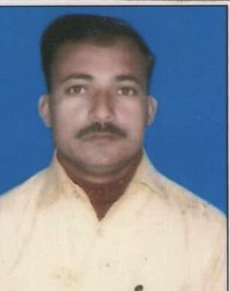
RESUME
RAJU KUMAR
E-mail-rajukumar4028@gmail.com
rajuacjeevika@gmail.com
Date of birth 25-03-1979 |  | Mobile -07070972026,  07485804939
Nationality Indian

CAREER OBJECTIVE

To build my career in Corporate and looking forward for a challenging and intellectually stimulating working environment where one can learn, grow and achieve. Seeking a position to utilize my skill and abilities in corporate world.

WORK EXPERIENCE

JOB | - Working as team leader BOOND A DROP OF HELP BIHAR from  15/01/2005 to 30/08/2007  - Working as PRS at BRDS(MNREGA) Bihar from 10 SEP 2007 to 22 AUG 2013.  - Working as AREA CO-ORDINATOR BRLPS,SRLM, NRLM Bihar from 23 Aug 2013 TO till time.

EDUCATIONAL QUALIFICATION

Post Graduation | MBA (HR) From SU, MERRUT (U.P.)
Graduation | BA (Hons) From MU BODH GAYA BIHAR
Inter | Bihar Intermediate Education Council, Patna
Matric | Bihar School Examination Board , Patna
 | COMPUTER SKILLS
Application Package | MS-Office, Tally 9.0 and older, DTP.
Operating System | Win95/98/XP/NT/2000/XP/07/08.

INTERESTS & ACTIVITIES
Interests | Interacting with People.  Music, Movies, playing.

PERSONAL INFORMATION
Father’s Name | Shri Umesh Prasad
Sex | Male
Marital Status | Married
Permanent address | Vill- Bakaur, Po- Paithana, Nalanda, Bihar 801303
Correspondences Address | Savitri Sadan, Gayatri Mandir Road, Parwalpur, Nalanda 803114
Languages | Hindi, English and Bhojpuri

Strength | - Goal – oriented team player.  - Meticulous in work and diligent.  - Never says die attitude.  - Self confidence.

Expectation & Remuneration | - Achievement oriented with excellent people management skills  and an ability to manage change with easy.  - Hardworking with a fertile mind for new ideas.  - Proven strength in trouble shooting, problem solving, coordination  and analysis.  - A good team player with ability to lead a team by example and  motivate them to achieve desired objectives.  - A confident, intelligence individual with an ability to learn fast.  - Helping other members in team to produce better results  - Excellent communication, presentation, negotiations skills  - Experience of corporate and social both culture/sector.  - The Management should help me to make decision of my own to achieve the target set by the management from time to time.  - After all I need a friendly environment to grow as an individual also.

I hereby declare that the above-mentioned information is true to the best of my knowledge and belief.

Date:
Place: -BIHAR (Raju kumar)

