Resume

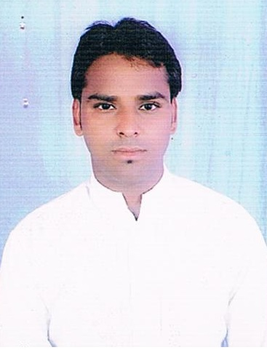
Balveer Singh rawat
Vill- Nayagoan,Post-Rajgarh,
Tehsil.-Nasirabad,Ajmer (Raj)
Mob-09829420309,9929534956
E-mail: naveensinghr@ymail.com

Career objective

To obtain long-term Bright Future in field of Operation, at the basis of my Knowledge & Job quality and Will to give full satisfactory service to the company or organization for It’s higher development along with my Good communication & Technical Skill with creativity.

Degree | Institute/University | Year | Division | Percentage
B.C.A. | Maharshi Dayanand Sarswati University, Ajmer | 2010 | IInd | 58.68

Standard | School/Board | Year | Division | Percentage
12th | Government School Rajgarh Ajmer (R.B.S.E.) | 2007 | IInd | 47.62
10th | Government School Rajgarh Ajmer (R.B.S.E.) | 2005 | IInd | 48.53

Techical Knowledge

Operating System | Microsoft Windows
MS-Office | MS- Word, Excel, Power Point, Access.
Languages | English,Hinde
Typing | English 24 W.P.M. Hindi 20 W.P.M.

Experince

1 year Work as a Office Assistant in ,computer oprater“Grameen Evem Samajik Vikas Sanstha, Parbatpura Ajmer” (N.G.O.).
1 year Work as a IT Maniger in ,computer oprater“N.I.C Ajmer” .

Hobbies

Net Surfing
Making Friends

Personal Profile

Father’s name: Mr. Laxman Singh Rawat

Date of Birth: 10th oct. 1987

Gender: Male

Marital Status: Single

Declaration:

I hereby declare that particulars given here in are true and complete to the best of my knowledge and belief and I will produce necessary documents as and when required.

Date:
Place: Balveer singh

