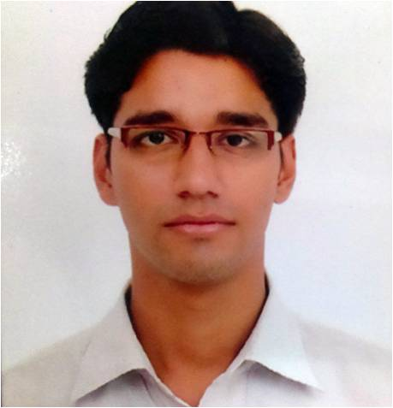
Nitin Kumar Sharma

(Java Developer with Spring, Hibernate, Struts 2, Alfresco Experience)
1771, 3rd Floor, Rani Bagh, Delhi-110034
 : +91-93-508-04400 : nk_sharma@outlook.com

Objective
Programmer with a knowledge purview of Java and .net programming along with latest framework like springs, struts, hibernate & most reliable databases. Successfully delivered Business oriented projects, ITSM tools and Support/ Customizing CMS.

Employment Snapshot

Since Oct’10 - HCL Infosystems Ltd. (Software Engineer)

Roles and responsibilities: Serving skills delivering many critical applications for HCL Care with Latest frameworks and architecture.

Projects
Successfully deployed many Business oriented applications in HCL Care like
SOL3 | SOL for Blackberry | Mea Support
Aeon CRM | Warranty Portal | AMC portal
Successfully deployed Employee-centric Applications for HCLites
RRC (ITSM Tool) | CATS (Timesheet) | Alfresco
Sales Force | C-Pulse | ESOP

May’08 to Sep’10 – Strategic Design Pvt. Ltd. (SharePoint Admin)

Roles and responsibilities: Administration and maintaining company’s SharePoint Server Farm, installation, site creation, definition, content management, customize web part handling, doc’s library & mail handling, backup & restoration of site.

Aug’03 to May’08 – Kaushik Orthopaedic Pvt. Ltd. (Sr. IT Executive)

Roles and responsibilities: Maintaining and enhancing KOC CRM. Developed customize software for ISO audit (DMS) Inventory Management and Sale Management (Java Based Web application). Configuring & managing users & data, Scheduled backup and other reports.

Project Detail

SOL3: This application is designed For HCL D2C Customer and for ASP who are running
Customer Care/ Repair Center for HCL Care.
Main Modules: ASP SO Management, Key-User- ASP handling, Demand Mgmt, Reporting.
Technologies used: Spring, JDBC, Web Service.
URL: http://service.hclinsys.com/sol3
Service Online: This application is designed For HCL Care Blackberry Repair Center.
Main Modules: Jobsheet Creation, DOA Creation, RMA Management, Reporting.
Technologies used: Struts 2, JDBC, Web Service.
URL:http://care.hclinsys.com/bb
CATS/CATS Phase 2: This application is Replica of SAP Common Application Timesheet module.
Main Modules: Timesheet Creation, Timesheet Approval, Task Creation and Mgmt, reports.
Technologies used: Struts 2, JDBC, PI.
URL: https://hclite.in/cats
CPULSE: This application is used for customer Feedback management.
Main Modules: Feedback form, Questionnaire creation and customer mapping, reporting.
Technologies used: JSP, Servlet, JDBC.
RIM Integration: Standalone programs for RIM SOL Integration
Main Modules: Order Response, receipt, triage, Symptom Action, FD Shipment, Escalation.
Technologies used: Spring, JDBC, Web Service.
CATS-JDC: Standalone programs for RIM SOL Integration
Main Modules: Timesheet Creation, Timesheet Approval.
Technologies used: Spring, JDBC, PI.
ESOP: This application is related to HCL Employee Stock Option Plan.
Main Modules: For Managing Employee Shares.
Technologies used: C#, MS-SQL.
Mea Portal: This application is designed For HCL D2C Customer and replica of SOL3 for Mea Customer
Main Modules: Serial Number Registration, Jobsheet Creation, reporting
Technologies used: Spring, Hibernate.
URL:http://service.hclinsys.com/MeaSupport
Warranty & RIM Portal: This application is designed For HCL D2C Customer and RIM RMA management.
Main Modules: RMA, Management, Warranty Management, Reports.
Technologies used: Spring, Hibernate.
URL:http://service.hclinsys.com/RimUpload
RRC: ITSM & Service Management (ITIL Compliance) application
Main Modules: Service Incidence monitoring, Change Management, Escalation Management, User/Admin Management/ Reporting/Schedule Program
Technologies used: Spring, Hibernate.
URL:http://intranet.hclinsys.com/HelpDesk
Nokia ASA: Standalone programs for RIM SOL Integration
Main Modules: Order Response, receipt, triage, Symptom Action, FD Shipment, Escalation.
Technologies used: Spring, JDBC, Web Service.
Alfresco: CMS & Workflow management application
Main Modules: CMS, Document Library, Workflow
Technologies used: Spring, JDBC, Web Service, Hibernate, JSF
URL: https://hclite.in/share
KOC: ERP for Kaushik Orthopaedic Pvt. Ltd.
Main Modules: ERP System for store, Sales, ISO Document management
Technologies used: JSP, Servlets

Technical Skill set
Programming Languages | : | Java, J2EE (Exp-6 Years)
Databases | : | Oracle, MySql, Postgres, MS-SQL (Exp-4 Years)
Web Server/Application Server | : | Apache Tomcat, Glassfish, Web Logic(Exp-4 Years)
Development Tools | : | Eclipse, MyEclipse(Exp-6 Years)
Web Technologies | : | JSP, Servlets, Html, JavaScript, AJAX.(Exp-5 Years)
Frameworks | : | Spring (Exp-2 Years), Struts (2) (Exp-4 Years), Hibernate 3.0.(Exp-2 Years)
Operating Systems | : | Win XP, Win 7, Linux.(Exp-6 Years)

Detail of Qualification and Professional Education

Technical Qualification
- MSC (IT) From Punjab Technical University (1st Div.).in 2008th
- 1 Year Diploma in Computer Applications and Programming from F-tech

Academic Qualification:
- B.A.( Pol. Sc. H.) from Delhi University in 2006
- Sr. Sec. (12th) from C.B.S.E. (S.S.S.V, Nehru Vihar). in 2003
- Higher Sec. (10th) from C.B.S.E. (S.S.S.V, Nehru Vihar). in 2001

Languages Known:
I am Fluent in English & also in my Mother tongue language-Hindi.

Personal Detail

Date of Birth : 23rd Aug’85

Marital Status : Married

Current Address : 1771, 3rd Floor Rani Bagh, Delhi-110034

Contact Number : 09350804400

