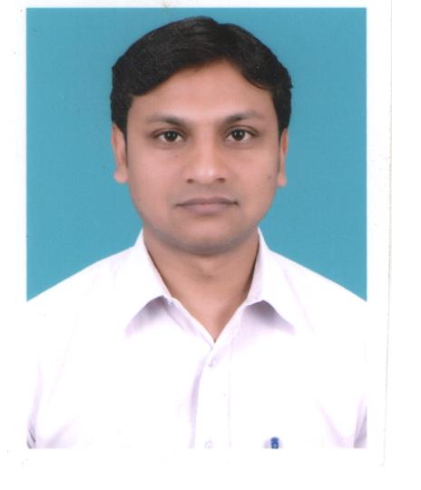
RAHUL KUMAR
MOB- 9899416586,9871638686
D-247A Mahavir enclave Part III New Delhi-110059
E-mail- raj.rahul.k@gmail.com

EXPERIENCE:
Approximate 4.0 years of experience in IT Industry, mainly development of Web based and client-server Applications. Possess strong problem analytical skills with ability to follow project standards and procedures as per client specification. Have been involved in full SDLC on the project of Web based application and in Government domain. Got involved in Requirement gathering, Design, Development Experience in web application development using Java, j2ee, struts framework, Hibernate, Ajax, and Servlets & JSP. Exposure to Myeclipse 5.5, JBoss 4.0.4 and Tomcat 5.5.1.

PROFESSIONAL QUALIFICATION:
- MCA (Master of Computer Application) From IGNOU with 61%
- ADCA(Advance Diploma in Computer Application) From IGNOU with 62%
- BCA (Bachelor of Computer Application) From IGNOU with 61%

EDUCATIONAL QUALIFICATION:

- 12th with an aggregate of 77.77% from BIHAR Board
- 10th with an aggregate of 59.47% from BIHAR Board
TECHNICAL SKILLS:

- Programming Languages : JAVA\J2EE, C, C++.
- Web Tecnology : JSP,Struts, Servlets, AJAX, Hibernate.
- Servers :JBoss 4.0.4, Tomcat 5.5.17.
- RDBMS : Oracle 10g, Oracle 9i, PL\SQL Developer
- Operating Systems : WindowsXP, Linux.
- Domains : Financial, Government Domain.
- Tools : My Eclipse 5.5, Jasper Reports / I-Reports.

PROJECT UNDERTAKEN:

Zebra Infotech. (June 2010 to Till date.)
I. Project Name: OIL DRDC SUPPORT
Client: Oil India Ltd.Data Recovery Data Centre.
Tool & Skill Used: Eclipse 5.5, Java, J2EE, JSP, Servlets, Java Scripts, Oracle
Durations: Jul 2010 to till date.
Project Details: Developing OIL INDIA DRDC SUPPORT comprehensive, flexible recovery options tailored to meet OIL INDIA specific technical requirements. Provides a wide range of solutions and highly complex recovery environments. Helps an actionable online document so, it can quickly and cost-effective.
Role: Team member
Designation: Programmer
Team Size: 6
Location : Noida (Onsite)

2.Project Title: Human Resource Management System( Aug 2009 to May 2010)
Tools Used : JSP, Servlet, JDBC, Apache Tomcat 5.0, Oracle 9i
Company :Zebra Infotech
Client : Zebra Infotech
Team Size : 4
Role : Coding, implentation
Description :This project is an integration of the employee record management, salary management, employee recruitment process, and customer record management and appraisal management. This project is made of the four module. Details about the employee are stored in the centralized database. This database also has the information general user, customer and their feedback. In recruitment process, what are the conditions of customer to associate with the company? In the salary management process salary is selected by the employee grade and how much DA and HR is added in the salary
3. Project Title : FMIS (MP Treasury) Feb 2009 till July 2009
Tools Used : My Eclipse 5.5, Dream Weaver, and RDBMS: Oracle 10g, Java,
J2EE, Jboss, Struts, Ajax, Hibernate etc
Client : MP Govt
Team Size : 12
Duration : Feb, 2009 to July, 2009
Role : Team Member
Company : CMC LTD.
Description : This was a Migration Project, in which Oracle-D2K based application is migrated on java\j2ee based technologies. The MP treasury system is managing the treasury system of MP Govt. Using this government easily can manage the DTI Manager, Budget Allotment, Loan Management, User Management, and FMS(File Movement) Menu. Using this government can easily manage the budget and loan that’s provided on the basis of the requirement.

4. Project:-DVAT Sept 2008 till Feb 2009
- Customer: DEPTT. OF TRADE & TAXES, DELHI

Description
DVAT is a browser based centralized database application software for sales & tax department.It caters various processes related to dealer business/ interfaces with in Sales & Taxes Department, like Dealer Registration with Department, Return Submission, Form Controls, Assessment etc
Role: Team Member
Company: CMC LTD.
Solution Environment JavaScript, JAVA, Oracle Reports, PL/SQL
Tools: JDeveloper, Oracle Report Builder, Jasper Report.
Highlights
Module Leader- Handling the modules of the DVAT project. It includes coding, manual testing of coded module.Involved in client Interaction for project requirements.Also involved in code review and deployment activities. DVAT Project, Front end is developed in J2ee environment, Database and Application Servers both are of Oracle 10g. Even user interface id developed on Oracle 10g Developers

PERSONAL PROFILE:

Date of Birth : 3rd March 1983
Father’s Name : Shri Chandrama Rai
Sex : Male
Language Known : English, Hindi.
Interests : Listening to Music, Watching Cricket & Playing
Passport No. : G8117402

I hereby declare that the information furnished above is true to best of my knowledge and belief.

Place: New Delhi (RAHUL KUMAR)
Date:

