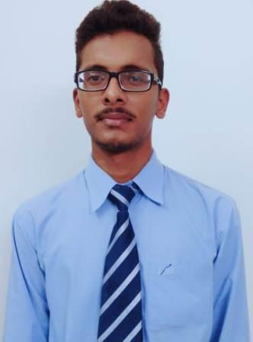
AKASH YADAV
+91-8299451354, +91-9532147386
akashyaduvanshi028@gmail.com
Skype ID: akashyadav280697@gmail.com
LinkedIN ID:akashyaduvanshi028@gmail.com
______________________________________________________________________________________
CAREER OBJECTIVE
To be a part of an organization where I can acquire a challenging position utilizing my strengths and earn a job which provides job satisfaction along with achieving personal as well as organizational goal.

ACADEMICS
COURSE | INSTITUTE & BOARD/UNIVERSITY | YEAR OF PASSING | Percentage  %
MBA (Pursuing)  Major-Marketing  Minor-Human Resource | Doon Business School/Uttarakhand Technical University | 2018-20 | Awaiting
B.Com | University Of Lucknow | 2018 | 50.7%
12th | St.Fidelis College  (ISC Board) | 2015 | 53.8%
10th | St.Fidelis College  (ICSE Board) | 2013 | 61.6%

INTERNSHIP(S) &TRAINING(S)
Underwent 2 months internship from August, 2019 to October, 2019 in DECATHLON SPORTS INDIA PVT.LTD. where I had to handle the responsibilities of “Marketing Associate”.
Did Winter Internship Training in U.P.ASBESTOS (UPAL) where the project of study was “Distribution Channel”.

ACHIEVEMENTS
- Unlocked GOOGLE DIGITAL Certification of Fundamentals of Digital Marketing.
- Certificate of Participation for Online Quiz on “Prevention and Control of COVID-19” conducted by Journal of Pharmaceutical and Biomedical Research.

- Certificate of Participation in Webinar on “National Integration Most important Need of Present Bharat” conducted by UNIAC.
- Certificate of Participation in Webinar on “Employability Opportunities and Hurdles in Post Covid Scenario” conducted by JAIPURIA SCHOOL OF BUSINESS, INDIRAPURAM, GHAZIABAD.
- Certificate of Participation in the Online Webinar on “OVERVIEW OF MERGER & ACQUISITIONS” conducted by Faculty of Management Studies (FMS) GURUKULA KANGRI VISHWAVIDYALAYA, HARIDWAR, INDIA.

TECHNICAL SKILLS
Basic Knowledge of MS Office Tools like Word, Excel as well as TALLY also.

STRENGTHS
Ability to work in a team and individual environment.
Strong and quick acquiring of new technologies.
Result driven and smart worker.

Co-Curricular Activities
Participated in various Group Discussion Activities.
Organized and managed various cultural events and activities.

Languages Known
English and Hindi

Date:
Place: (Akash Yadav)

