LISTENING MUSIC

WATCHING TV

PLAYING CRICKET

SIWAN (BIHAR)

+91-8540009760
deepakcse71@gmail.com

EDUCATION
PROFILE
CONTACT
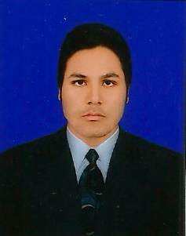
CURICULAM VITAE

DEEPAK KUMAR

To secure a challenging position in a reputable organization to expand my learning, knowledge, and skill.
- 10TH PASS FORM BSEB BOARD PATNA
- 12TH PASS FORM BSEB BOARD PATNA
EXPERIENCE
- THREE MONTS TRANING DIGITAL
MAMAPPING IN :- MATRIX GEO SOLUTION
PVT LTD
SKILL
- HINDI AND ENGLISH
HOBBIES
LANGUAGE KNOWN
- BASIC KNOWLEDGE OF HTML
- BASIC KNOWLEDGE OF CSS
- MS WORD
- MS EXCEL

- ADCA FORM SHANTI INSITITUTE TECHINICAL DEGREE COLLEGE (GORAKHPUR)
- BCA(DEL) FORM JAIPUR NATIONAL UNIVERSITY (JAIPUR)
- MBA(DEL) FORM JAIPUR NATIONAL UNIVERSITY (JAIPUR)
PROFESSIONAL EDUCATION

