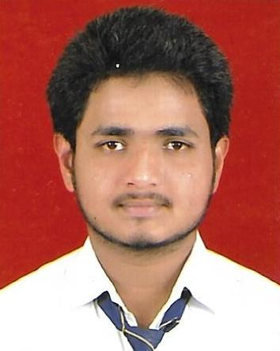
CURRICULUM VITAE
KAMRAN QAMAR
B-441 Rajajipuram
Lucknow-226017
Mob.9005772489
Email :-kamransheikhsiddiqui786@gmail.com

CAREER OBJECTIVES
To be a part of an organization which offers opportunity for enhancement of professional skills and self–esteem.
ACADEMIC QUALIFICATION

- Pursuing M.B.A(Tourism) from Lucknow University.
- B.B.A.(Tourism) from Lucknow University in 2017.
- Intermediate Passed from ISC Board in 2014.
- High School passed from ICSE Board in 2012.
OTHER SPECIAL QUALIFICATION
- Computer Basic Knowledge.
- 1 Month Diploma in Francis DU Tourisme
WORKING EXPERINCE

- 4 months Internership from SOTC Holidays.

PERSONAL PROFILE
Father’s name : Mr. Rashid Qamar
Date of birth : 07/11/1997
Nationality : Indian
Gender : Male
Languages known : Hindi &English
Hobbies : Playing cricket & Listen Music
Soft skill : Hard working & time management

I here by declare that all information given in this C.V. is correct to best of my knowledge and belief.
Date: ………….
Place: Lucknow (KAMRAN QAMAR)

