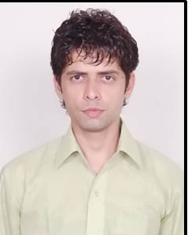
Deepak Kumar Tiwari
117 Samar Vihar Colony Alambagh Lucknow
e-mail id: deepak619it@gmail.com; Mobile:7755891157

SUMMER INTERNSHIP 20 April- 20 June 2017

- From Hettich Pvt. Limited at Kanpur
- Sales and Promotion of Hettich screws

Corporate exposure at Sharp India, Noida

- Analyzed the consumer perception for Sharp India at Noida Sector 125,127,132,137
- Analyzed the market perception about Company
- Have increased the number of sales of Printer

Marketing Live Projects

- At Spar Hypermarket, Ghaziabad
Corporate Exposure in Retail Industry

ACADEMICQUALIFICATIONS

- PGDM (Pursuing), Jaipuria Institute of Management, Noida, 2016-2018,52%
- B.Tech (IT ) IEM,College,Mathura, 2008-2012,60.90%,
- Higher Secondary Schooling, SVIC,Lucknow,60.49%
- Secondary Schooling, SVIC,Lucknow,44.50%

CO-CURRICULARACTIVITIES

- Participated in NukkadNatak

ACHIEVEMENTS

- Have done daily soap Kya hua tera wada

INTERESTS

- Acting
- Watching movies
- Travelling
- Reading articles

