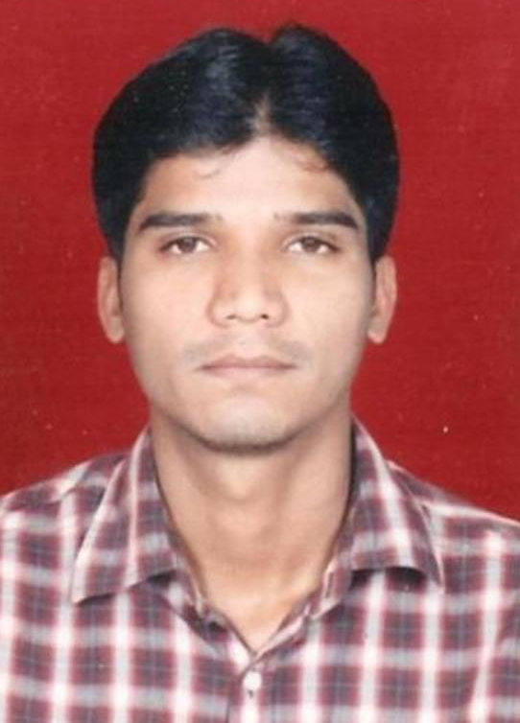
Resume

AMAR M. SAPATE

Contact : +91 9673614361
E-mail : amar.sapate@gmail.com

Career Objective:

- Aim to be associated with progressive and growth oriented organization that gives scope to apply my talent and skills with hard work and determination, and to be part of the team that dynamically works towards the growth of the organization..

Educational Qualification:
Degree | University/Board | Year | Percentage
MCA | S.G.B Amravati University | 2011 | 65.00%
B.COM. | S.G.B Amravati University | 2008 | 50.00%
H.S.C. | Maharashtra State Board, Pune | 2005 | 55.50%
S.S.C. | Maharashtra State Board ,Pune | 2003 | 65.20%

Technical Skills:

Operating Systems : Microsoft Windows (XP, Vista, Windows 7).

Computer Languages : C, C++, Core Java, Oracle.

Certification : Oracle Certified Professional, Java SE 6 Programmer.

Projects Undertaken:

Title : “ARTIFICIAL INTELLIGENCE TUTORIAL SYSTEM”

Technology : Java ,Mysql,

Description : Artificial Intelligence Tutorial System is base on the AI which is a Tutorial and Training system.This System provide user to give tutorial on the specific topic.It also provide the user with test series .To avoide unauthorized used to use the system.

Seminar Delivered:

Title: “OPTICAL CAMOUFLAGE”

Extra-Curricular and Achievements:

- Represented Under 14 Runner Up team in State Level Competition at Wardha in Volleyball.
- Participated in State Level Software Presentation Competition at the Ram Meghe Engineering College, Badnera.

Hobbies:

- Solving Mathematical and Logical puzzles.
- Communicate with people.
- Teaching

Strengths:
- Creative.
- Good team leader.
- Hard worker.
Personal Details:

Name : Amar Madhukarrao Sapate
Father’s Name : Shri.Madhurkar P. Sapate
Date of Birth : 14th October 1987.
Gender : Male.
Marital Status : Single.
Languages Known : English, Marathi & Hindi.
Address : Prashant Nagar, Vanrai Marg,
Amravati. Pin – 444 606.

Declaration:

I hereby declare that the above information is true to the best of my knowledge and belief.

Place: Amravati

Date: 16th June 2012

Mr Amar Madhukar Sapate.

