CURRICULUM VITAE
AMARDEEP KOUR
S/o Mr. JOGA SINGH
R.M.S. COLONY,MALIVIYAGANG,ITARSI
STATE - M.P., Pin- 461111
Email: - msg2akour@gmail.com
Mob: - 08103841724.

Career Objective
- T o work in challenging and stimulating environment, where I can learn and deliver my best for the dynamic growth of the organization and as well as my career.

Academic Qualification
Exam Board Year Percent
Board M.P.BOARD(BHOPAL) 2006 79.5%
Intermediate M.P.BOARD(BHOPAL) 2008 80.0%
Professional Qualification
Course University Year
BSc Computer B.U.(BHOPAL) 2008-2011 72%
M.C.A. RGPV 2011-2014 79%
Hobbies
- Singing song
- Working on project
- Interacting with friends

Key Skills and Competences

- Listening Skills
- Problem Solving skills
- Flexibility
- Professionalism
- Ability to work independently
- Self Motivated
- Better Understanding
- Better Computer Skills

Personal Information

Father’s Name : Joga singh
Date Of Birth : 29-09-1990
Sex : female
Marital Status : Single

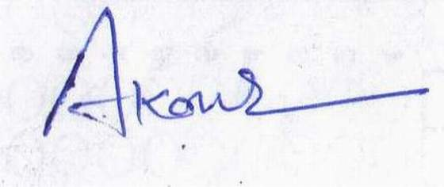
Signature
Date: 27-09-2013

Place: BHOPAL

