RESUME

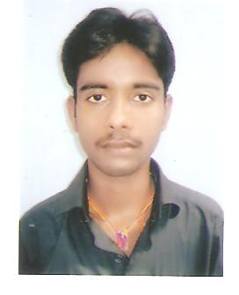
ASHUTOSH KUMAR

S/o : - Krishna Sahu
Village : - Aspura
P.o+P.s : - Bikram
Pin Code : - 801104
District : - Patna
Contact : - 9386834966,9204394205
Email : - ashu10015@gmail.com
Career Objective:-

To work in a challenging and stimulating environment, where
I can learn and deliver my best for the dynamic growth of the organization as well as my career.
Academic Qualifications :-
Exam  Passed | Board/University | Subject | Marks | Marks  Obtained | % of  Marks | Year of  Passing
Matriculation | B.S.E.B PATNA | All  Subjects | 500 | 248 | 48.40% | 2007
Intermediate | B.S.E.B PATNA | Science | 500 | 259 | 51.80% | 2009
BCA-I | M.U BODH GAYA | COMPUTER SCIENCE | ___ | ___ | 63.00% | 2012

Extra Qualification:-
FULL COMMAND ON MS-OFFICE, PAGEMAKER, Corel Draw, C, C++.
TYPING SPEED:- 35 IN ENGLISH & 20 IN HINDI.

Working Experience:-
CALL CENTRE IN CALL 2 CONNECT INDIA PVT. LTD. 6 (SIX) MONTHS

CANTEEN MANAGER IN UDYAN HOSPITAL INDIA PVT. LTD.3(THREE) MONTHS

Personal Profile:-

Name : - Ashutosh Kumar
Father’s name : - Krishna Sahu
Mother’ name : - Kalawati Devi
Date of birth : - 10th Jan 1993
Sex : - Male
Nationality : - Indian
Religion : - Hindu
Marital Status : - Married
Language Known : - Hindi & English
Declaration:-

I hereby declared that the information’s furnished above in true to the best of my knowledge.
Please Sir/Madam give me one valuable opportunity and I will be done my level best .l don’t have hope but full confidence you will give me this good chance.

Date:-
Signature
Place:-

