
Harshil Mehta

Date of Birth: 09/06/1989
Mobile: +919460772110
Email: romitmehta1@gmail.com
Degree: Bachelor of Technology (B. Tech.) University: Rajasthan Technical University, Kota
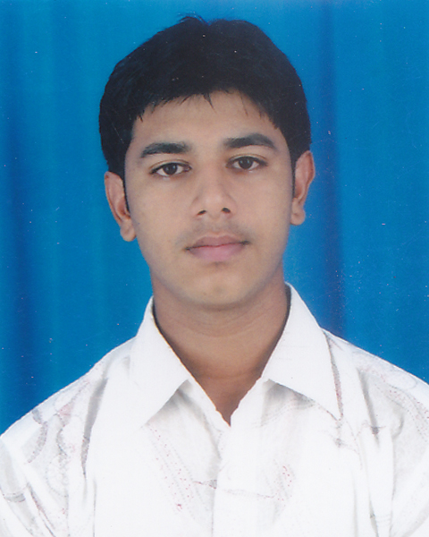

Career Objectives
I like to do work with an organization who worked with enriched enthusiasm, I like to show my skills to such company who appreciate my hard work for the development of company and I like to learn new things and technology with that company. I am the hard task master and struggling person. I know one thing about me that whatever work I do, it will be done from heart by me.

Educational Qualifications

Examination | Discipline/ Specialisation | Institute | Board/University | Year/Semester | Year | Result * (%)
B-Tech | CSE | Jodhpur Institute  Of Engineering  And  Technology | Rajasthan  Technical  University | VIII Semester | 2012 | 85.0%
 |  |  |  | VII Semester | 2012 | 75.1%
 |  |  |  | VI Semester | 2011 | 76.4%
 |  |  |  | V Semester | 2011 | 73.8%
 |  |  |  | IV Semester | 2010 | 70.6%
 |  |  |  | III Semester | 2010 | 69.5%
 |  |  |  | II Semester | 2009 | 65.8%
 |  |  |  | I Year | 2009 | 74.3%
XII | PCM | Sardar Children’s  School | RBSE |  | 2008 | 62.7%
X |  | Sardar Children’s  School | RBSE |  | 2006 | 74.5%

Training/Industrial Visits

Company | Duration | Description
Core Infocom Pvt. Ltd. | 30 days | Software Testing

Projects/Workshops

- Workshop on “Microsoft Technologies” held at MBM College in Jodhpur on October 17, 2010.
- Developed “Payroll” in C++ in 4th Semester.

- Developed “Library Management System” in 5th Semester In-house project using Visual Basic 6.0 as front end tool and My SQl as back end tool.

- Test the software “ Facility Management System” in Software Testing field during the training session in 6th Semester.

- Test the web base 121jobs.com application also and make test cases with bug report.

- Developing “Departmental Book” as major project using VB.net as front end and Sql Server as back end. This project is somewhat related to facebook. This is window base application.

Extra Curricular Achievements/Awards

- Achievements
- I was rewarded by the “Microsoft literacy certificate” on 9th April 2011.
- I was co-coordinator in general quiz in the college resonance in 2011-2012
- I was volunteer (Registration) in ICCET’10 held in Jodhpur Institute of Engineering & Technology on 13-14 November.
- I am the coordinator of Department ( CSE) Newsletter and Pixel Community.
- I created the logo of Pixel club (Club of CSE department) in 2010.
- IBM DB2 Certified.
- Also got certificate in blood donation camp.

Proficiency

- Languages : Hindi, English, Regional
- Computer Language : C, C++, bit knowledge of Java and VB.net, SQL Server (Back-end)
- Operating Systems: Windows XP, window 7, bit linux.

Personal Information

Name : Harshil Mehta
Father's Name : Mr. Rajendra Mehta
Sex : Male
Date of Birth : 09/06/1989
Martial Status : Unmarried
Nationality : Indian
Hobbies : Travelling to different tracking places, singing, and reading novels.

Permanent Address : 39/40 2nd A road Near Sindhu Bhawan, Sardarpura Jodhpur
(Raj.)

Phone No. : 0291-2611396
Mobile No. : 09460772110
Email : romitmehta1@gmail.com

