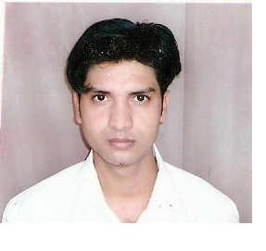
RESUME

NAVED KHAN
A/190,Surya Vihar,
Secector -4,
Gurgaon, H.R-122001
Email: naved.rahil@gmail.com
Phone-09015749155

Objective
To seek a challenging position in Documentation and Library Environment where I can utilize my expertise and public relation skills as a Library Information Professional.

Core Competencies
- Library Automation and Digitization
- Library Management Software i.e. Libsys, SOUL ,Alice for Windows,and VTLS
- Barcode Technology
- Radio Frequency Identification (RFID)
- Online Searching
- D-space
- GSDL

Technical Proficiencies
- Platform: Windows 95/98/NT/2000/XP
- Languages: HTML, Perl, and PHP, Fox Pro
- Tools: Microsoft Office Suite (Word, Excel, PowerPoint, Access)
- Database: CDS/ISIS, WIN ISIS

Professional Experience:

20,July 2009 to till date Librarian in Institute of Information Technology & Management, Vill.Silani, Sohna Gurgaon,H.R

Major Responsibilities:
- Set up the Library
- Automation of the Library
- Management of print and online journals

July 2007 -June 2009 date Librarian in Ram Gopal College of Pharmacy,Sultanpur,Farrukh Nagar,Gurgaon,H.R

Major Responsibilities:
- Classification and Cataloguing of books
- Acquisition of Books
- Circulation operations
- Management of print and online journals
- Providing Reference Services to the users
- Providing Information Services

July 2005- June 2007 Asstt.Librarian in SRMS College of Engineering & Technology Bareilly,U.P.

Major Responsibilities:
- Classification and cataloguing of books
- Acquisition of Books
- Automation of Library

Professional Qualification

1st Class Bachelor in Library and Info.Sc A.M.U Aligarh 2004
1st Class Master in Library and Info.Sc, A.M.U,Aligarh 2005

Educational Qualification

2nd Class Bachelor of Arts (English), A.M.U, Aligarh 2003
2nd Class Intermediate, U.P.B, Bareilly 2000
2nd Class High School, U.P.Board, Bareilly. 1998

Language: English, Hindi, Urdu

Personal Detail

Father’s Name : Mr.Akiq Khan
Date of Birth : 15/08/1982
Nationality : Indian
Sex : Male
Passport No. : G3694244

NAved KHAn

