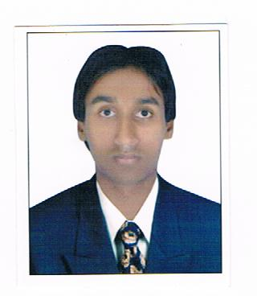

CURRICULUM VITAE

Mr.Rinku Singh
PERSONAL INFORMATION:
Date of Birth : 01/07/1990 Marital Status : Single
Father’s Name : Mr. Shrichand Nationality : Indian
E-mail id. : Rinkuvaid9634@gmail.com
Languages Known : Hindi, English
Phone No. : +919319998002;+917428485114
Address : H,458/17 Sangam Vihar New Delhi 110062
CARRIER OBJECTIVE
To work for an organization that will bring best of my talent utilize my skills to the fullest and help me to achieve goals of the organization.
PROFESSIONAL QUALIFICATION
2010-12 : MBA With Dual Stream {HR&Marketing} from Institute of Informatics & Management Sciences, Meerut College Affiliated, MAHAMAYA TECHNICAL UNIVERSITY, NOIDA Formally {U.P.T.U}

2009-2010 : One year Diploma in Computer.
From; Navbharat computer education Meerut
ACADEMIC QUALIFICATION:

2010 : BBA from I.I.M.S College Meerut
2007 : 12th from Govt .Inter College Meerut
2005 : 10th from Govt.Inter College Meerut

COMPUTER PROFICIENCY:

One Year Diploma of computer Tally 9.0{E.R.P}

Ms Office : - MS Word, MS Excel, Power Point.
: - Good Knowledge of Internet

WORK EXPERIENCE :

Two Months in NTL Electronics India Ltd.

PROJECTS UNDERTAKEN:

Attended a project entitled Recuitment & selection at NTL Electronics India Ltd. {Dehradun}

STRENGTH:

Smart working, positive thinking & Co-operative.
BEHAVIOURAL SKILLS
- Stress management, Building self esteem.
- Working in groups.
- Team building, Interpersonal skills.
ASSOCIATIONS & ACTIVITIES
- Participant in Quiz competition in college.
- Active participant in cultural activities.
- Active participant in the field of sports.
- Participated in various debates, presentations in college.
LINGUISTIC ABILITIES

- Proficiency in English, Hindi

REFERENCE:

Furnished upon Request...

DECLARATION:

I hereby declare that all the information furnished by me is correct to my knowledge and beliefs.

Date: ……………..
Place: …………….

[Rinku Singh]

