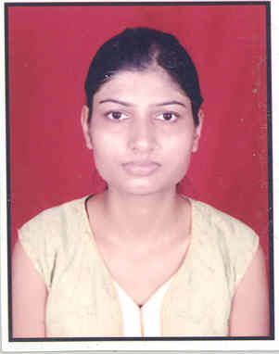

Monika Agarwal

09/241, TrilokPuri New Delhi-91
monika.agarwal84@yahoo.com
91-9718705488, 9873980489

Career Objective

Seeking a position where I can prove myself as good assets of organization and use my skills and experience for best output.

Academic Qualifications

Year | Degree | University | Percentage of Marks
2009 | MCA | H.N.B Garhwal University | 72%
2004 | Bsc (PCM) | Kumaon University | 61%
2001 | XII | UP Board | 55%
1999 | X | UP Board | 55%

Work Experience

1. 8 months work experience in Java

Project Name File Tracking System
Organization National Informatics Centre, New Delhi
Duration Feb 09 to Oct 09
Designation Project Trainee
Technologies Servlet, JSP, HTML
Database Postgresql Server
Team Size 8

Role:
- Gathering information flow for our module.
- I played coding and testing part on Report Module of this project.

Description:
File Tracking System- FTS is a web based application to monitor the pendency of receipts and files and assist in their easy tracking. It is an integrated package which has features right from diarizing of receipts/files, updating its status, opening of new files, tracking the movement of files, dispatch of letters/files and finally records management.

This is developed by National Informatics Centre, based on the Central Secretariat Manual of Office Procedures of the Department of Administrative Reforms & Public Grievances.
Academic Project

Project Name Student Management System
University H.N.B.Garhwal University Srinagar Garhwal
Technologies Core Java (Front End)
Database MS Access
Team Size 2

Role:
- Collecting information flow
- Database creation
- Testing and coding

Description:
Student Management System is an academic project that mainly concern on storing the information of the students. When the students are enrolled in University, then their various details like name, father’s name, age, qualification, studying course etc are stored in database. In future, Administrator can delete or modify the student’s information.

IT Skills / Software’s Worked On
Languages Core Java, Servlet and JSP, HTML, XML, C, C++
Database postgresql server, MS Access
System Window (XP, 2000)
Web Server Apache Tomcat 6.0
Strengths

- Self Motivated
- Positive Attitude
- Adapting Changing Environment
Personal Details

Date of birth 07/09/1984
Father’s Name Mr. R. S. Agarwal
Permanent Address Avas Vikas Colony EWS 288 Haldwani, Uttarakhand
Language Hindi, English
Marital status Single
Nationality Indian

(Monika Agarwal)

