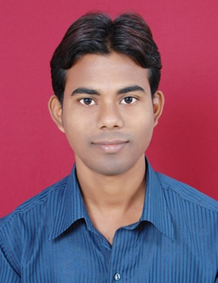

Tukuna Maharana
C/o-Mahesh Kumar
C-Block, C-1246, JJ Colony
Tigiri, Khanpur Extension,110062
Mobile: +919861650280
Email:tmaharana261@gmail.com

OBJECTIVE:
In serve with a dynamic and growth oriented organization which can utilize the inherent talent of the incumbent to the maximum. It’s my pleasure to work on challenging and dynamic projects with good amount of freedom and responsibility as well as which can contributes meaningfully to objectives of the organization.
EDUCATION QUALIFICATION:
1. BCA from Berhampur University in 2010.

EXPERIENCE DETAILS:
- One year experience in Planman Technologies Pvt Ltd(New Delhi), as a Quality Executive (From 11th Jan-2011 to 15th Jan 2012).
- Two year two months experience in Dhanei kgfs Pvt Ltd (Berhampur), as a Wealth Manager Executive (From 02nd -Sept -2013 to 30th –Oct-2015).
- One year two months experience in L&T Finance Service (Berhampur), as a Associated.(From 26th –Feb-2016 to 05th May-2017).
- Seven months experience in RMSI (Noida), as a GIS Analysis (From 02-09-2017 to 25th -03-2018).
- Currently working in Mapmy India (Okhala Ph-3,New Delhi ), as a GIS Analysis (16th -04-2018).

TECHINICAL SOFTWARE:
- Web designs in HTML,XMl,Photoshop,Illustrator.
- Database in Oracle 9i (SQL),P/L Sql,My sql.
- MS-Word & MS-Excel & Autocad,ArcGIS,QGiS,MapInfo,Digitization.

HOBBIES:
- Listening music, playing cricket, swimming in ponds, flying kites.

PERSONAL PROFILE:
Name : Tukuna Maharana
Date of Birth : 11th Feb 1990
Father’s name : Mangulu Maharana
Mother’s name : Basanti Maharana
Sex : Male
Marital Status : Married
Languages Known : English, Hindi and Oriya
Nationality : Indian
STRENGTH
- Enthusiastic, confidence, patience, eagerness to learn from adverse situation, trust worthy and love to work in a team.
DECLARATION:
- I hereby declare that all the above statements made in this application are true, complete and correct to the best of my knowledge and belief.
Place:
Date: (SIGNATURE)

