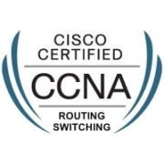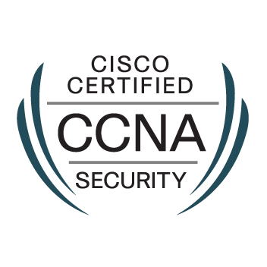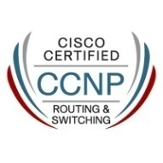
MANAS KUMAR JYOTISHI
CELL-(+91) 7008402754, 9583271135
EMAIL ID: manasjyotishi.miet@gmail.com
CAREER OBJECTIVE
A Challenging Career in a reputed organization which will help to develop my abilities and skills in the field of NETWORKS.
AREAS OF EXPERTISE
- ROUTING – RIP, EIGRP, OSPF, IPV6 ROUTING
- SWITCHING - INTER VLAN ROUTING, STP,CST,PVST ,PVST+,RSTP, MST, VLAN SECURITY, VLAN ACL,VTP VERSION 3 ,ETHER CHANNELSPAN R SPAN,PORT SECURITY
- VPN- GRE, IP SEC , M-GRE ,DM VPN,SVTI,GET VPN,VRF AWARE VPN
- TECHNICAL SKILLS IN BGP, HSRP, VRRP , GLBP , NAT , ACL
- BASIC KNOWLEDGE ON NEXUS SWITCHES-7K,5K,2K(VDC,VPC,STP WITH VPC,FABRIC PATH,OTV), MPLS, ASA FIREWALL(NAT,ACL,FAILOVER,CLUSTERING,VPN)
- WORKING EXPERIENCE ON SWITCH STACKING AND VSS
- SKILLS ON BASIC AAA SERVICES, DHCP, QOS, MULTICASTING, NTP, IP SLA, EEM, WCCP
WORKING EXPERIENCE
Company-Mahindra Defense System Ltd
Duration-December 2019 to till date
Designation-Network Cum Security Admin (DATA-CENTER)
Roles and Responsibilities:

- Identifying, diagnosing, and resolving network problems.
- Monitoring All data center Physical devices Through NNMI.
- Monitoring all data center virtual devices Through OBM.
- Working on ASR 1004 Router,4500 series Switches.
- Implementing OSPF on Router.
- Managing ASA.
- Implementing VSS in 4500 Series switches and stacking on 2960-X series switches.
Create the Networking Infrastructure.
- Working on port security.
- Assist in the preparing of survey reports, the Network design & LAN diagram according to the site requirements..
- Installation & configuration of L3 switch.
- Participating in 24x7 on-call rotations.
- Managing network infrastructure.
- Trouble shooting network connectivity & various network problems.
- Providing the support to the entire infrastructure
- Internet and Network Troubleshooting, Coordination with the ISP regarding links fault.
- Traffic filtering using ACL.
- Basic Implementation and trouble-shoot on NEXUS switches.
Company-Wipro Info Tech
Client-National Informatics Center, New Delhi
Duration-May 2018 to November 2019
Designation-Network Engineer
Roles and Responsibilities:

- Identifying, diagnosing, and resolving network problems.
- Implement VPN connections.
- Settings of the networking devices (Cisco Router, switches) co-coordinating with the Network administrator during implementation.
- Create the Networking Infrastructure.
- Performing complex implementation and maintenance tasks on the LAN
- Installation & configuration of L3 switch.
- Monitoring network performance through whatsup gold..
- Providing the support to the entire infrastructure.
- Backup/Restore the configuration of CISCO Routers and Switches using TFTP.
- CISCO IOS Up gradation using TFTP.
- Internet and Network Troubleshooting, Coordination with the ISP regarding links fault.
- Traffic filtering using ACL.
Company- Gayatree institute of technology Betnoti ,Odisha
Duration-May 2014 to August 2017
Designation-Network cum Service Engineer
Roles and Responsibilities
- Configure antivirus software
- Monitor the performance of the computer systems and address issues as they arise.
- Provide technical support for software reconfigurations to aid in function customization.
- Test software performance throughout the desktop network to ensure peak performance.
- Install computer hardware and software on desktops to keep versions current.
- Initiate and complete Microsoft Windows server operating system updates.
- Managed laptops, desktops, and printers.
- Configure D-link router.
- Working as a CCNA trainer also.
CERTIFICATIONS

  - CCNA Routing and Switching (CISCO ID – CSCO 13409066)
  - CCNP Routing and Switching (CISCO ID – CSCO 12374098)
  - CCNA Security (CISCO ID – CSCO 13409066)
EDUCATIONAL QUALIFICATION
- B Tech Electronics & Communication, from BPUT university, Odisha in 2012 with 7.43 C.G.P.A.
- 12th from Seemanta Mahavidyalaya, Jharpokharia Odisha with 66%
- 10th from from M.K.C. High School, Baripada, Odisha with 81.87%
PERSONAL PROFILE

- Date of birth : 10th JULY 1991
- Father’s name : Mr.Adyapada Jyotishi
- Language known : English, Hindi & Odiya
- Contact Details : Safdarjang enclave,Krishna nagar gali no 7 New Delhi

DECLARATION

I do hereby declare that all the information provided above are authentic and to the best of my knowledge.

Place: New Delhi Signature

