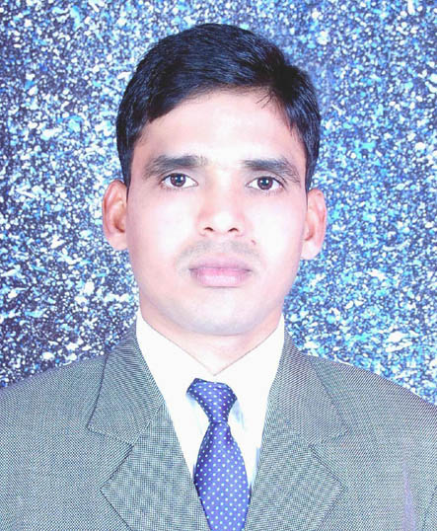
Mayank Johari

MAYANK JOHARI Contact address

mayank.jhr@gmail.com Mayank Johari S/o R.M. Johari
(+91) 9760323156 L.I.G. 53, Second Phase ,
Mahavidya Colony Mathura

CAREER PROFILE_
Objective

To work with an organization offering challenging work profile and conducive work environment, where my skills knowledge can be utilized and honed, so can contribute to organizational and personal growth.

ACADEMICS _

- B.Com Completed Dr. Bhim Rao Ambedkar University Agra.
- S.S.C. Completed U.P. Board, Allahabad.
- H.S.E. Completed U.P. Board, Allahabad.

PROFESSIONAL QUALIFICATION _

I have CCC (Course of computer concept ) in NIELIT.

EXTRA SKILLS _

- I have knowledge about Microsoft office (Word ,Excel ,PowerPoint) .

- My typing speed 25-30 word per minute in English (U.S.) & Hindi 20-25 word per minute.

- I have knowledge about Window and Software installation and formatting and system networking
and troubleshooting.

- Proficiency in internet surfing and mailing.

- I have knowledge about Organizing and maintaining files and records.

- Planning and scheduling meetings and appointments.

PERSONAL DETAILS_

- Father’s Name Mr. Ravindra Mohan Johari
- Date of Birth 30 Dec. 1984
- Sex Male
- Religion Hindu
- Nationality Indian
- Martial Status Married
- Language Known English, Hindi
- Permanent Address L.I.G. 53 , Second Phase , Mahavidya Colony, Mathura (U.P.)
Contact (hometown) - (+91) 9456221134

ORGANISATIONAL EXPERIENCE_

I have work with Aegis Bpo as a Customer Care Executive A-5, Sec 3 Noida from 16 April 2009 to 11 June 2010.

I have work with Universal Offset Printers as a Computer Operator cum Admin Executive Kanjari Sarai Moradabad from 5 Oct. 2010 to 10 Dec. 2014.

I have work with ICE Global Technologies as a Admin cum office Assistant E-15, Sec 3 Noida from 5 Jan. 2015 to 30 Dec 2016.

I have work with Manan Digital as a Senior Admin Executive FF-230, Krishna Apra Plaza Alfa-1 Greater Noida from 6 Feb. 2017 to 25 May 2018.

HOBBIES AND INTEREST_

- Surfing and browsing internet.
- Collection new invents software’s and operating system.

Declaration:

- The above statements are true to the best knowledge and belief.

- Date…………………
(Mayank Johari)
- Place………………...

