
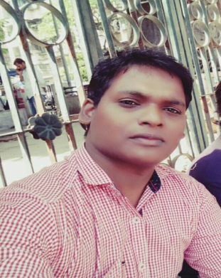



Linkedin.com/in/vikash-chauhan-39613151
WORK EXPERIENCE
4 +Years
Age 27
SQL SERVER IMPLEMENTATION ENGINEER
Mrr.vikas@gmail.com
VIKASH CHAUHAN
+91.9699141211
A young and dynamic Professional with near about 4+ years of cross-functional experience in consistently delivering responsibilities relating to Foreign Exchange,Tour and Travel, Retail Banking Operations, Profitability and Customer Satisfaction; determined to carve a niche in the domain of forex and financial operations.
Experience in SQL with implementation task as well as designing , writing queries, stored procedures, triggers and views,function and cursor.
Providing overall leadership to the entire project team including managing deliverables of other functional team leaders in an effective manner.
Sound Knowledge of core Java with PLSQL in Toureca Project.
Ability to handling contingencies to resolve systems bottlenecks within shortest time frame while building and nurturing relations with customers to ensure regular business opportunities and their prolonged retention.
Being an innovative, motivated and goal-oriented professional, I have consistently proven my ability to handle multiple operational and strategic levels of responsibilities

.

ABOUT ME


Education

- B.Tech from BBIET&RC GBTU Uttar Pradesh in 2012 Secured 68%.
- H.S.C from the Up board in 2008 Secured 55%.
- S.S.C from the Up board in 2006 Secured 73%.

Professional Qualifications and Affiliations

- Certificate of C,C++ from NIIT VARANASI Uttar Pradesh.
- SQL, SQL-SERVER ,T_SQL FROM SATHYA TECHNOLOGIES HYDERABAD
- ORACLE 10G,11G,CORE JAVA FROM NIT HYDERABAD.


Career Highlights

- 2 Year Experience in TECHNICAL SUPPORT ENGINEER in JRD SOFTWARE SOLUTION NOIDA UTTAR PRADESH from FEB-2014 to MAR-2016
- 6 Month SQL SERVER DBA training from DURGA SOFTWARE SOLUTION Hyderabad. From APR 2016 to SEP-2016.
- 2+ YEAR Experience in SQL IMPLEMENTATION ENGINEER in MARAEKAT INFOTECHPVT LTD
- FROM NOV-2016 TO DEC-2018 .

Skills

- SQL
- ORACLE 9I,11G
- SQL SERVER DBA
- CORE JAVA ,PLSQL
- T-SQL


Work Experience

WORKING at MARAEKAT INFOTECH PVT.LTD
Designation: Sr. IMPLEMENTATION ENGINEER
Duration: NOV-2016 TO DEC-2018
Project Name: EONENT,TOURECA
Job Profile:
- Communicate with client and is responsible for all aspects of implementation of software, and managing the initial stages of the client relationship.
- Installing SQL Server2005/2008/ 2012/2014 on the server providing connection and managing database.
- Manipulate data in database & importing excel sheet in database
- Backup and restoring databases.
- Creating Table, View, Store Procedure ,Index.
- Designing various types of Crystal reports for different client.
- Providing support to the client to handle different queries.
- Configured log shipping ,mirroring, replication with SQL server management studio.
- Creating and scheduling of maintenance plans (database backups, log backups, indexing task)

Responsibilities
- Involved in creating database tables ,view ,triggers, index
- Handling more than 4 server Clients and 20+ desktop client query related to application and data Base.
- Taking backup ,restore Database ,user login creation in sql server.
- Installing different sql servers for different client .
- Creating maintenance plans for client as for requirements.
- Working as daily role weekly role and monthly role for different task .
- Making different report as for business requirements.
- Helping server client as well as desktop client in application support
- Recover the database when database is in suspected mode.

JRD SOLUTION (P) LIMITED.
Designation: TECHNICAL SUPPORT ENGINEER
Duration: Feb-2014 to Mar-2016
Project Name: CRM ,HOSPITALITY

Job Profile :
- Solving daily client issue related software .
- Troubleshooting error related to dll,application error, mapping error .
- Backup database through application as well as sql server tool.

Responsibilities
- Daily Software related issue resolving through remote access.
- Installing different sql servers for different client .
- worked on Admin module
- Solving the query of client to help better .

Academic Projects

Title: Collaborative Whiteboard and televise.
Duration: 6 month
Technologies: Html,Css,JavaScript,Sql,Oracle ,Networking.
Description
- Developed the complete project with two people as well as analysis to testing.
- In this project master and user is there for communicating each other by audio video, chatting, drawing graphical. Master have all right to accept the user or reject .
- This project is small based organizations or for college domain

Responsibilities :
- Working and managing whole project within 6 month.
- Represent the project to dean and HOD.
- Designing database as well as module for master.
- Network configuration and troubleshooting.
- Project hard and softcopy Preparation.


Languages

- English
- Hindi


Personal Interests

- Gaming
- Reading book
- Social helping

- Net surfing
Personal Skill

- Ability To learn by own
- Ability to retrieve & acquire
- Use methodology, observe, classify.
- Hard work with planning
Personal Details

- Father’s Name: SSS CHAUHAN -
- Marital Status : Married
- Dob : 15-jul-1992
- Nationality : Indian
- Gender : Male
- Address : Room no 201 Shanti Avenue Charni Pada Bhiwandi
Thane (421305)Maharastra.
Declaration
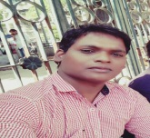
I, Vikash Chauhan, hereby declare that the information contained herein is true and correct to the best of my knowledge and belief.

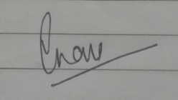
____________________________
Vikash Chauhan Bhiwandi Thane, Maharashtra

