CURRICULUM VITAE

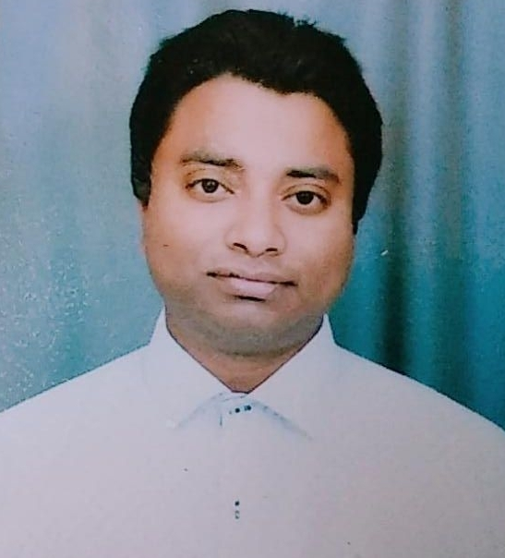

CAREER OBJECTIVE
To work with a progressive organization and utilize the opportunities available to grow academically and professionally while contributing my best to the growth of the organization.
ACADEMICS RECORD
- Graduated in B.Com (pass) from Delhi University in the year 2007
- Higher Secondary from C.B.S.E in the year 2004.
- Senior Secondary from C.B.S.E in the year 2002
PERSONAL QUALITIES
- Good Communication skills in written & verbal both
- Critical thinker & quick learner
- Very good telephonic & email draft skills
TECHNICAL SKILLS

Programme | : | Completed 1 year diploma in Computer application programming course from F-Tec
Expertise in Advance Excel | : : | Vlookup, H-lookup,Pivot Table & Pivot Chart , Nested IF, Sum If & Sumifs,Countif & countifs, Index , Match, offset, Sumprodut, Subtotal,datedif, iferror and various other excel sheet components for accurate data.
Typing speed | : | 45 WPM (in English)

PROFFESSION EXPERIENCE

1. 3 Years 03 Months Experience with M/s SMC Insurance Brokers Pvt. Ltd. since Nov 2016 to till date as MIS Cum Life Insurance Operations Executive.
Job Responsibilities
- Coordinate with all Sales team regarding Login of Policy business on daily basis.
- Responsible for update policy details of client on company software as per received MIS files
- Mail received & sent and coordinate with office assistant regarding Query.
- Tolerable Confirm of pan card , Adhar card and ITR documents on related website
- Organize report of daily ,Weekly & Monthly business MIS Reports by using Pivot table & Pivot chart and forward to the Head of Dept.
- Provide recommendations to update current MIS to improve reporting efficiency and consistency.
- Good team player and flexible enough for multitasking

PREVIOUS COMPANY PROFILE

2. 1 Year 5 Months Experienced with M/s Shakshi Financial Pvt. Ltd.since April 2015 to October 2016 as MIS Executive in Finance Job Responsibilities
- Maintain & arrange Maturity amount for all Branches (More than 50 Branches.
- Release & Approved Commission of agent (as per previous month business of agent, calculate the commission of agent as per rank)
- Coordinate with All branch in charges regarding Maturity Amount via telephone & Mail.

PREVIOUS COMPANY PROFILE

3. 2 Years & 9 Months Experienced with M/s Studium Press India Pvt. Ltd’s Researchco Book Centre from August 2012 to April 2015 as Computer Operator Cum Administration Executive .
Job Responsibilities
- Dealing with the Vendor for Cost Analyses of Products and Equipments
- Responsible for all aspects of order of books from client
- Obtaining quotations from the Books publishers and coordinating with them through mail and telephone.
- Analysing the discount & finalising the details of titles with price & discount & placing the order to various Publishers.
PREVIOUS COMPANY PROFILE

4. 4 Years Experienced with M/s Corporate Services from Feb 2008 to March 2012 as Sr. Executive – Administration and Operations.
Job Responsibilities
- Arrange new Phone Lines connection for all Branches of the company.
- Billing and payments & Full and final settlements of the bills.
- Coordination with Venue Manager & Office Assistant regarding Phones and office equipment requirement & Arrange the same with immediate effect .
- Responsible for payment of all pan India telephonic bills on time
PERSONAL DETAILS

- Father’s Name : Sharif Ahmad
- Nationality : Indian
- Language known : English / Hindi
- Marital status : Married.
HOBBIES

- Listening music
- Internet Surfing
Date:

Place: Delhi-(India ) ( Md. Sabir)

