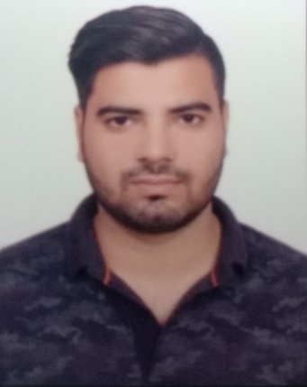
NISHANT KUMAR
Male, 23
Qutub bihar, Dwarka sec-19
New Delhi-110071
Email :-nishantsistec@gmail.com
Contact No :-8435730504
CAREER OBJECTIVE
Looking for a challenging career which demands the best of my professional ability in terms of, technical and analytical skills, and helps me in broadening and enhancing my current skill and knowledge.
ACADEMIC DETAILS
Year | Degree/Exam | Institute | Performance (CGPA or %)
2017 | B.E.(ECE) | Rajiv Gandhi Technical University, Bhopal Madhya Pradesh | 7.41 CGPA
2013 | 12th | BSEB,PATNA,BIHAR | 66.6%
2011 | 10th | BSEB,PATNA,BIHAR | 76.4%

PROFESSIONAL EXPERIENCE:

- Current Company Name: Renovision Automation Service Pvt Ltd
- Profile – Desktop Support Engineer
- Duration: – Current Employer since Oct 2018 to Present
- Client Name: – WIPRO Client Site (RBL Bank)

Work Responsibilities:
- installation and troubleshooting of operating system windows 8 &10
- Configuration and troubleshooting Microsoft outlook accounts
- Installation of software like an antivirus, MS-office, etc.
- Installation, Troubleshooting and updating of Symantec endpoint Antivirus
- Knowledge of Remote Desktop Connection
- Working & understanding of ticketing tool.
- Knowledge of Remote Desktop Connection
- Knowledge of Ticketing tool.
- Previous Company Name :- Jeet Infotech
- Duration: June 2017 to July 2018
- Job Profile: - Desktop Support Engineer
- Solve internet related problems configuration basic TCP/IP settings
- Knowledge in software and hardware installation and troubleshooting
- Installing, managing & troubleshooting of MS Outlook.
- Installing of Win XP, Win 7, Win 10 and create profile.
- Configuring, managing, monitoring and troubleshooting of complete Desktops, Laptops and Printer.
- Installation and configuration of DNS and DHCP.
- Installation and configuration of Active Directory.
- Knowledge of Remote Desktop Connection
- Installation, configuration and maintenance of Local and Network Printers.
- Understanding of Ticketing Tool.
- Installation and configuration of Antivirus
PERSONAL SKILLS
- Adaptability, Creative and Innovative thinking, Leadership skill.
- Quick learner, Good Time management and Hard worker
.
PERSONAL PROFILE:-
- Name :- NISHANT KUMAR
- Father’s Name :- Mr. PREM KUMAR THAKUR
- Mother’s Name :- Mrs. SUJITA KUMARI
- Hobbies :- Playing Cricket, Listening Music
- Date of Birth :- 4 Aug 1996
- Sex :- Male
- Marital status :- Single
- Nationality :- Indian
- Languages Known :- English, Hindi

DECLARATION:-
I hereby declare that the above information given by me is true to the best of my knowledge and belief.

PLACE:-
DATE:- Nishant kumar

