CURRICULUM VITAE
JANAKI RAM PANDA  Bhoop Singh Colony  House Number-10E  Rajpur Khurd  Chhatarpur, New Delhi  E-Mail: Janakipanda85@gmail.com  Ph. no- +91-9560646349 | 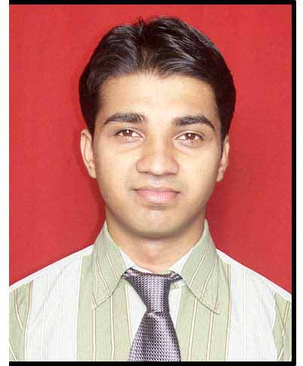

CAREER OBJECTIVE:
Looking for a challenging role in a reputable organization to utilize my technical, database, and management skills for the growth of the organization as well as to enhance my knowledge about new and emerging trends in the IT sector.

EDUCATION QUALIFICATION:
Completed MCA from Biju Patnaik University of Technology in the year 2009.
Completed B.SC from Berhampur University in the year 2005.

CAREER PROFILE SUMMARY:
- Total 10 years of experience in IT Industry in EDB Postgres, PostgreSQL, and including 3 years of experience in Database Administration in Oracle Technologies.
- Working In IL&FS Environmental Infrastructure & Services Limited from June 2010 to 7-June-2019 in different platforms as mentioned below.
- Working as a SQL Supporter from June 2010 to April 2012 in IL&FS Environmental Infrastructure and services Limited.
- Working as Oracle DBA from May 2012 to August 2015 in IL&FS Environmental Infrastructure and services Limited.
- Working as PostgreSQL DBA from August 2015 to June 2019 in IL&FS Environmental Infrastructure and services Limited.
- Working as Lead Administrator in Wipro Technologies from August to 06-June-2020.
- Working as Production DBA III in Kronos from August to 08-June-20 to till date.

RESPONSIBILITIES
- Installed Oracle softwares(11g & 12c), configured Listener and TNSNAMES functions.
- Participated in all phases of the system development life cycle from requirements analysis through system implementation.
- Auditing, Trouble shooting, Monitored and tuned database performance.
- Collaborated with development team to tackle database/application issues.
- Involved in all phases of database development, from needs assessment to QA/QC, design, and support.
- Exposure to oracle utility RMAN for backups and AWR/ADDM reports from Oracle 10g/11g database and analyzed the reports for identifying on-going/proactive issues, Oracle wait events, time consuming SQL queries, table spaces growth, and database growth.
- Expertise in Analysis, Design, Development, & Implementation of Business Applications using Oracle 10g/11g (SQL, Performance Tuning).
- Tuning autovacuum parameters to ensure up to date table stats and reclaim space consumed by dead tuples
- Prepares and/or reviews activity, progress, and performance reports.
- Diagnoses, resolves and implements preventive measures to prevent problems for availability, recoverability and performance of all supported database environments.
- Install, configure, test, monitor and upgrade new and existing PostgreSQL databases.
- Proactive managing standby replication methodologies like Streaming replication and hot standby for disaster recovery.
- Scheduling daily Point in time recovery (PITR) to the development environment for proper product testing.
- Developed and tested storage strategies and disaster-recovery plan for large manufacturing company’s operational database, delivering solution that guaranteed recovery performance and high availability.
- Enhanced users’ understanding of database systems by conducting pre-implementation workshops, delivering group and individual training sessions and creating user-friendly training materials.
SKILL SET:
RDBMS: PostgreSQL (9.3,11), Oracle (11g/12c)
Operating System-Windows & Unix
Backups-Logical, Physical, Incremental and Differential backups
High Availability-Hot Standby, Streaming Replication
Solution: Web Application, Windows Application.
Tools/Utilities: SQL Developer, RMAN, Toad, Enterprise DB, Oracle Enterprise Manager (OEM), Pg_Dump, Pg_Dumpall, Pg_Basebackup, DB Comparer for PostgreSQL

PROFESSIONAL EXPERIENCE:

1-Project Name-AIRTEL AFRICA
Client-Airtel Arica
Description: Airtel Africa is a global client for Wipro Limited. Business for nearly 14 OPPCO are
managed by Wipro Limited
Duration-27-Jan-2020 to Till Date.
Role-Lead Administrator
2- Project Name-PMKISAN
Client-NICSI
Team Size-15
Duration-26-Aug-2019 to 26-Jan-2020
Role-Lead Administrator
3- Project Name-National Communications Institute of Mozambique (INCM)
Client-Telecoms and Internet Service Provider of National Communications Institute of Mozambique (INCM)
Team Size:-6(DBA)
Duration-February 2018 to Till Date
Role-PostgreSQL DBA
4-Project Name: E-Governance Project under JNNURM Program
Client Name: Housing & Urban Development Dept. (HUDD, Bhubaneshwar)
Team Size: 4(DBA).
Duration-August 2016 to January 2018
Role-PostgreSQL DBA

5- Project Name: India Meteorological Department
Client Name: Government of India.
Team Size: 2(DBA)
Duration-December 2014 to July 2016
Role-PostgreSQL DBA
6. Project Name-Environmental and Social Policy Framework
Client Name: - Environmental Management Centre, Mumbai.
Team Size: 04(PostgreSQL DBA).
Duration-May 2012 to November 2014
Role-Oracle DBA
7. Project Name-E Registration (Odisha)
Client Name: - Government of Odisha.
Team Size:-04
Duration:-June 2010 to April 2012
Role-SQL Supporter
ACHIEVEMENTS:
- Received Appreciation Letter for Customization of Database to improve faster generation of operational rainfall reports From Deputy Director General of Meteorology, India Meteorological Department, New Delhi
- Performed CMMI 5 level Activities during SDLC process and maintain process compliance.Highly motivated with the ability to work effectively in teams as well as independently.
PERSONAL PROFILE:
Father’s Name : Rajkishore Panda
Mother’s Name : Manorama Panda
Nationality : Indian
Date of Birth :1st June 1985
Permanent Address :At- Agraharam street
Po- Gunupur
Dist-Rayagada (Orissa)
Pan Card Number : AZCPP9294N
Hobbies :Reading Newspaper, Listening Music
Languages Known :English, Hindi, Oriya
DECLARATION
I hereby declare that he above mentioned information is correct up to the best my knowledge and I bear the responsibility for the truthfulness of the above mentioned particulars.

Date:
Place: New Delhi Janaki Ram Panda

