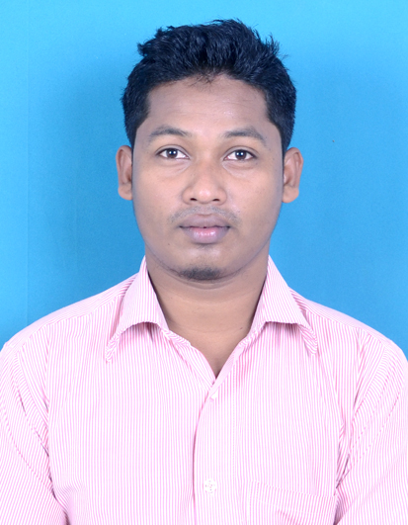
CIRRICULAM VITAE

Name:SANDEEP BIRUA Email:sandeepbirua04789@gmail.com
Mobile:+91-6200027995

Career Objective

To secure a challenging position where I can efficiently contribute my skills as IT Professional possessing competent IT skills.
Academic Qualification
Degree | Year of Pass | Subject | Pass Percentage
Graduation | 2013 | BACHELOR OF COMPUTER APPLICATION | 71%
XIIth | 2008 | PHYSICS,CHEMISTRY,BIOLOGY,HINDI  ENGLISH | 54%
Xth | 2006 | MATH,SCIENCE,SOC.STUDIES,HINDI,ENGLISH | 64%
Work Experience | 2 years working experience at Php developer in PB Technologies Pvt Ltd. Worked on e-commerce application.
Project Handled | - Banking system using VB frontend and Sql as backend .team leader of group of 7 members  - Online Library system using java front end and ms access as back end with team member of 8 .  - Online Hotel Reservation using ASP.net and oracle as Back end from NIIT Rourkela.  - E-Commerce Project in PHP using mySql as database.
Achievements | - Played NATIONAL IN CRICKET in SCHOOL,1ST PRIZE IN LONG JUMP,100mtr race in college, AWARDED BEST PLAYER IN CRICKET IN COLLEGE
Personality Skills | Attitude Enthusiastic, Goal Focused, /Self-Aware, Self-Confident ,Creative, Detail-Oriented Emotionally Competent Friendly ,Hard Working, Intelligent Relationship-Oriented , Trustworthy, Visionary
Certificates | Asp.net  CEH CERTIFIED  Oracle
Technical Proficiency | PHP,ASP.NET,JAVA,ORACLE,C,C++,SQL, Pursuing Python
Languages Known | ENGLISH,HINDI
Extra-Curricular  Activity | CRICKET,ATHLETIC,FOOTBALL
Personal Dossier
Address :village –Parasi, post office –Pilka ,dist-West Singhbhum Jharkhand
Father Name : P.C.Birua
Date of Birth : 04 JULY 1989
Gender :MALE
Personal Id No :6200027995
Blood Group :B+

