SANJAY SHARMA

Date of Birth: August 23rd 1983 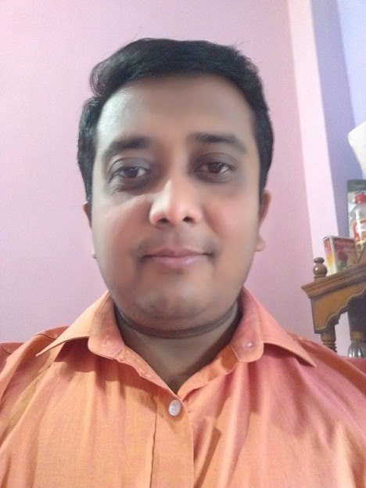
Address: H.No-316, Om Nagar, Mitthapur,
Badarpur, New Delhi-110044 E-mail: nrosanjay@yahoo.com
Mobile: +91 8700653791
- A young, ambitious and result-oriented individual who can consistently learn, contribute and upgrade the professional domain.

PROFESSIONAL SYNOPSIS AND ACEDEMIC CREDENTIALS

QUALIFICATION | YEAR | % OBTAINED | INSTITUTE
CA Final Group I | May’13 | 51% | ICAI
CA PCC Group II (CA Inter) | Nov’10 | 51% | ICAI
CA PCC Group I (CA Inter) | Nov’10 | 50% | ICAI
Common Proficiency Test | Feb’ 07 | 58% | ICAI
Graduatio(Science) | May’ 07 | 60% | Ranchi university
Class 12th | Mar’ 00 | 48% | WBBSE
Class 10th | Mar’ 98 | 62% | WBBSE

COMPUTER PROFICIENCY
- MS Office Tools | - Internet and Related Package  - Knowledge of Tally

WORK EXPERIENCE
Rakesh Neeraj & Co. (CA Firm Delhi)- 10-July 2010 to 31- Dec-2012.
S.P. Power (Gurgaon/Delhi) - 15 Jan-2013 to 30-11-2014
JD INTERIORS PRIVATE LIMITED 1.12.2014 TO CONTINUE_________

Experience of Accounting of business firm.
- Experience of Statutory/ Internal Audit.
- Preparation of project report for financing, MIS reporting.
- Expenses Scrutiny
- Scrutiny of Cash Vouching
- Scrutiny of Bank Vouching
- Expenses Vouching
- Exposure in Income Tax
- Tally, ERP 9, Inventory, Payable , Receivable.
- Cash Book , Imprest A/c
- TDS, VAT& CST, Service Tax, GST, Compliance and filling of Return also.
- Follow of Vendor , Debtors, Creditors
- Preparation of Bank Reconciliation statement, Also reconciliation Account Payable & receivable.
- Expenses Vouching, MIS Report to the management
- Exposure in Tax Return Filling of Individuals/Partnership/Pvt Ltd Co./Trust
- Cash Flow & Fund Flow Statement.
- Knowledge of GST and Filling of GSTR -1, GSTR-4 & GSTR-3B return, Reconciliation of Input Mismatch.

ADDITIONAL INFORMATION
Personal skill : Confident, Good verbal and written communication skill and team performer.
Strength : Optimistic, Focused and Practical.
Language Known: English, Hindi and Bengali.

Date:-
Place:- New Delhi Signature

