Govind Lal Suthar
PHOTO
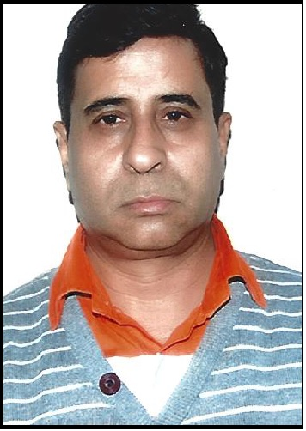
Dy General Manager Electrical & Instrumentation
(Retired from Ambuja Cements Ltd)
Mobile: 9815772726
Mail id : glsuthar@gmail.com
City of Residence : Delhi

Worked in Electrical Automation & Instrumentation Head in Project Management, Maintenance Operations with a leading organisation in manufacturing & Energy field .

Present Job Profile :
- Retired from Ambuja cements Ltd and worked as Head of Deptt with Ambuja Cements Ltd.(HOLCIM- LAFFARGE GROUP), at Ropar Punjab (India)as Deputy General Manager (Electrical, Automation,Instrumentation and plant maintenance). I was heading E&I Deptt with a team of 35 persons which includes 12 Engineers , 23 Electricians & Fitters.

- Technical Competency:
!32 KV Switch yard, 6.6 KV Siemens vaccum circuit breakers panel, LT & HT motors , LT Switch gears ,Variable Speed AC & DC Drives , UPS , Air Conditioners ,Electrical safety compliance , Isolation & Lock Out compliance, Hazard Identification & Rectification, Lightning protection system, Effectiveness of plant electrical & electronic machinery earthing system , Honeywell TDC 300 system, Honeywell Experion system, Rockwell PLC system , All kinds of electronic weighing system, Field Instrumentation , 2*15 MW BHEL Turbine & Generator, 45 TPH multi fuel based Thermax Boiler , Honeywell Fire Alarm system, Honeywell CCTV system , Electronic Packer machines etc.
Industry worked : Cement & Power Plant

Other Competencies

- Working with computerized based SAP maintenance.
- MS Office experience.
- Safety & Security – Observes safety and security procedure; Reports potentially unsafe conditions;
- Working on ISO 9001,14001 & ISO 18001
- Electrical safety, Isolation & lockout , working at height and lifting and supporting

Work Experience :

From August 1995 & retired on 28th Feb 2018 (Last Job)
Ambuja Cements Ltd at Ropar Punjab
Deputy General Manager (Electrical & Automation)
Highlights: Heading Electrical & Instrumentation Deptt

From April 1987 to August 1995

Birla Corporation
Dy Manager Instrumentation

Sept’1981 - March’1987: JK Lakshmi Cement, Sirohi Rajasthaan
Junior Engineer

Education :
Diploma in Electrical Engineering from Mohan Lal Sukhadia University in 1981
Institution : College of Technology & Agriculture Engg Udaipur Rajasthan

BTech in Electrical Engineering from IET Campus Lucknow in 2003

Personal Detail :

Date of Birth : 02/02/1960
Languages Known: English & Hindi

Present Address:
Flat no 1228, Sector-4
RKPURAM
New Delhi-110022

Nationality: Indian
Marital Status: Married
No. of Dependents: 2
Passport No.: M6081779
Passport validity : 11/02/2025
Visa Status: 10 years Visitor visa for USA & Canada
Driving License: Valid license for India . Licence no PB-1220080030408

Last salary : Rs 18 Lacs per annum with furnished accommodation.
Expected Salary : Negotiable
Notice Period : Not applicable

