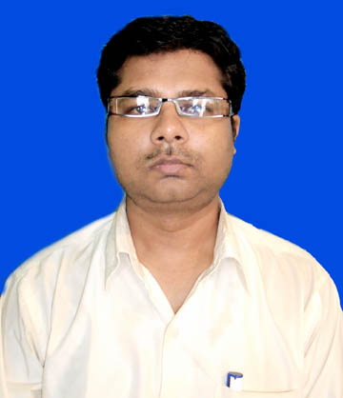
RESUME

Personal information
Name: Rajeev Ranjan
Marital Status: Married
Phone Number: 9430467911
Residential Address:kurji,patna
Email: rajeeev.ran@gmail.com
Date of Birth: 01/03/1981

WORK EXPERIENCE:
1.Working in Bihar prasasanik sudhar mission society as Information technology assistant(software installation and networking) and provide training to assistants from july 2011 to november 2012

2. Working as an it faculty and as an employee in admerit, Patna from 18 FEB 2013 to 31 AUG 2013

3. Working as a faculty in nimats, Patna from 4 SEP 2013 to 10 Feb 2014
4 working at nielit, Patna as a project associate from 17th of February 2014 to till date.

EDUCATIONAL DETAILS:

MASTERS - Master of Computer Applications (MCA) from
Lalit narayan mishra institute of economic development and social change patna(2005-2008)with 62% and Master of Science from veer kuwar singh university ara in 2005 with 72 % of marks in mathematics

BACHLERS-Bachelor of science fromVeer kuwar singh university ara (1998-2001)with 65% in mathematics.

INTERMEDIATE- Intermediate of science from Bihar intermediate educational council patna Bihar(1996-1998) with 63 % of marks in Maths

MATRIC- Matriculation from H D jain high school ara of Bihar School examination board patna Bihar in 1996 with 66% of Marks.

Details of.net course - Completion of .net course in December 2008 with A+ grade from HTS Delhi.

Technology used : Microsot .net

Databases : Microsoft sql server
Languages : c#,Asp.net, Visual Basic.
Internet Technologies :HTML XML
Operating Systems : Windows Family.

PROJECT DETAILS: -

1ST Project.
Project Title : A Project report on medical test
Duration : February 2008 to july 2008
Software’s Used : Microsot .net , c# ,microsoft sql server
Client : Single window operation
Role : Software developer
Project Description :

This project comes under the domain of HealthCare. The actual goal of this project is to deal with medical. appointment schedule, Patient Information, and and generate Customized report. It is a tool for solo or 2 - 8 physicians that contains all the financial clinic, operational elements of a successful running project.
Responsibilities:
Involved into preparing Functional Test Cases.
Involved into execution of Functional test cases and identifying the diseases and
preparing the Test report sheet

2ND Project .
Project title : A Project on payroll system in visual c# 2008.
Software’s Used :Microsoft visual c#
Client: Single window operation
Role: Software developer/engineer.
Project Description : This project comes under the domain of estimation of salary of various departments employees in various sectors.

3rd project
Project title: RTPS
A Project on online certification and offline certification of caste, residence, income, mutation and revenue and land reforms named as Adhikar

Role: assistant works of it in block level , Admin and maintenance of software,
Software installation data entry online certification and different concerns related to conduction of project with collectorate.

4th project

Project Title: A project on employee training online examination of group ‘C’ employee and group ‘D ‘ employee of secreteriate of Bihar government

About the project:
The examination takes place in two modes employee ---Direct examiner and trained examiner
The employee who get training of fifteen days in authorized institution are called trained employee .These two mode examiner appear in same examination and after passing the examination they get increment in their salary
Role: Project Associate
Data verification, online management of software and observer and examination superintendent of examination held after each two months, Data entry and photo upload in forms
5TH Project: CSC (COMMON SERVICE CENTER) Manpower

6th Project: BSDM (BIHAR SKILL DEVELOPMENT MISSION)

Current salary-15500/month

