CURRICULUM-VITAE

ANURAG DOHAREY  34, treveni nagar,  ghari bhadoriya,  Agra (U.P)  Phone- 9808422028  0562-2510126  Email- tomgun007008@gmail.com  tomgun007008@yhoo.co.in | Birth Date:- 28/10/1987  Birth Place:- Agra  Nationality: India  Languages: English, Hindi  Married  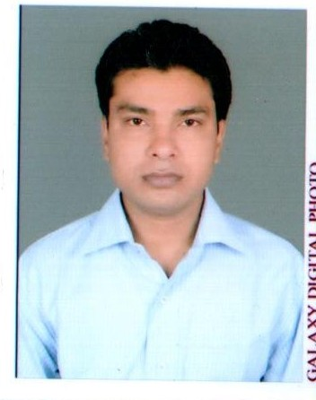

CAREER SUMMARY:
High caliber in Sales, Marketing & Business development strategies experience. Excellent relationship with customer skills, successfully and consistently delivering the responsibilities of revenue generation, profitability and market share customer and distributors satisfaction. Self-starter with proven expertise to set up sales & operations, establish company products and launched with excellent track record of driving business operations to profitability.

AREA OF EXPERTIZE:
Sales & Marketing
Business Development
Customer Service:
Client Relationship Management

MAX LIFE INSURANCE PVT.LTD| April2018 to March 2019

Associate Agency Development Manager
KEY RESPONSIBILITIES:

- Recruitment New Agents and long term to generate the business.
- Development of Team Members Prospecting lead habits, Appointment – Meeting Scheduling

- Co-ordination with Team member to Application forms logged-in.

- Doing Field observation and demonstration with new agents

- Motivate team member on achieving targets and Lead generation

- Attending Office Leadership meeting requirement for Branch Performance.

- Organizing Office Meeting in first week of every month with Team Members and Supervisor and keep the plan for the monthly in front of the Branch Manager.

Home credit India Finance Pvt. ltd | Aug 2016 to March 2018
Sales Associate
KEY RESPONSIBILITIES:
Bike loan, Home Appliance Finance, Personal loan, Collection

- Responsible for lead generation and calling to customers for finance Bike, Home Appliance and Loan settlement.

- Setting monthly targets, and achieving all targets.

- Tracking of skip cases to resolve them.

- Successfully increase and analyze the collections data.

SKILLS & STRENGTH:
- Lead generation Sales Management. Sales Operations.

- Business Development. Market Planning.
- Tracking of skip cases and resolve them

ICICI Bank in Off Roll (D S A)| April 2014 to July2016
Sales Executive(SME)
Bank provides lead and visit customer (KYC)
KEY RESPONSIBILITIES:
Micro Finance, Personal loan, Business loan, Home loan, CA/SA

- Responsible for calling to customers for credit card and Business loan, Personal loan ,Home loan

- Setting monthly targets, and achieving all targets.

- Tracking of skip cases to resolve them.
- Leads generation.

Education
Inter from U.P. Board in 2004.
B.A. from Dr .B.R.A. University Agra in 2010
M.A. from Dr .B.R.A. University Agra in 2012.
EXTRA EDUCATION
Computer Hardware & Networking. 2010
Diploma in Computer Application. 2011 UP (DIC)
Tally Accounts Manual& Computer. 2012
STRENGTHS
Positive Attitude & Confident.
Performing the role as a team-player.
Smart work.
Date:-

Place: Agra (Anurag Doharey)

