RESUME
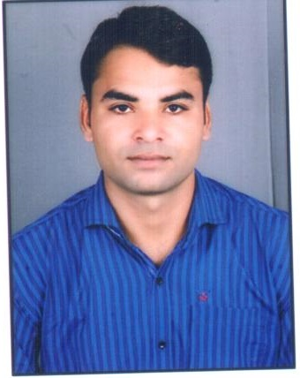

Er. Susheel Chandrawanshi
Add. - Chhindwara (M.P.)
Mobile : +91-8085262967, 9399893722
Email Id : besushilkm@gmail.com

Career Objective

To work in an organization, that will utilize my skills and in process help me to grow professionally & personally.

WORK EXPERIENCE:-

Organization/Company | Designation | From | To | Total Experience
Quess Corp Ltd. | Logistic Trainer | 16 Jan- 2019 | Currently Working | Working
Gathjod King Maker | Master Trainer/ Team Leader | July - 2018 | Nov - 2018 | 6 Month  (Contract Base)
Infinium Solutionz Pvt. Ltd. | Sr. System Support Engineer | Aug - 2017 | Dec - 2017 | 5 Month  (Contract Base)
Ernst & Young | Project Consultant (IT Officer) | Nov - 2015 | Jan - 2017 | 1 Year & 3 Month  (Contract Base)
Team Lease Pvt. Ltd. | Software Application Trainer | Feb -2015 | Oct - 2015 | 9 Month  (Contract Base)
NIIT Ltd. | Project Coordinator | Aug – 2012 | Dec – 2014 | 2 Years & 5 Month  (Contract Base)

Work AREA
- 5+ years’ experience in e-Governance sector (Advisory/Consultant) working with Govt. employee (Offices).
- 2 years experience of Training in Developing sector (NGO) working with State Health Department.
- I have been work as Supply Chain Management Officer in UNDP.
- I have lead a State label Project or work.
- Experience in Team built-up and manage a large team.
- Experience in field visit/monitor the project and support to Field Officer/Investigator.
- Experience in system upgrade and deployment.
- Good communication skills including experience interaction with clients and end-users.
- Experience in Training, Monitoring and Evolution, Reporting, MIS, UAT, PPT.
- Experience in Application Software Support, and implementations of software.

Project Done

PROJECT # 1: - Chhattisgarh Integrated Mines & Minerals Management System (ChhiMMMS)
Name of the Client: Mineral Resource Department MRD (C.G. Govt.)
Role: Functional Software Support Officer
Team Size: 50+
Project Description:

Chhattisgarh Integrated Mines & Minerals Management System (CHiMMS) is a Centralized Application system for Mineral Resource Department intended to automate the Mines & Minerals operations across the state and optimize the throughput of Mines & Minerals operations.

The CHiMMS application will reduce manual and redundant data entry efforts at all Project Locations sites and enhance data sharing and decision making.

PROJECT # 2: - Electronic Vaccine Intelligence Network (eVIN)

Name of the Client: UNDP (National Health Department)/MP Health Department.
Role: IT Officer
Team Size: 50+
Project Description:

This main project aims to provide quality immunization. In this project we are consulting for maintain the Cold Chain Room. And we are providing an online mobile/window based application which is connected to all CCP, DVS, and RVS through a single network. It is an online system.

PROJECT #3: - Crime & Criminal Tracking Network & System (C.C.T.N.S.)

Client: UP Police & National Crime Record Bureau (NCRB)
Team Size: 200+
Role: Technical Lead and Master Trainer.
Project Description:

The project objective is to standardize & automate police station processes nationally and implement a nationwide core application that would facilitate the delivery of the police station functions to the citizen and internally to the department.

This projects main aim is to connect all the police station in a single network.

Education

- B.E. in Information Technology 2008 – 2012
L.B.S.I.E.T. College, Jabalpur (M.P.) GPA: 73.64%

- Higher Secondary, Class 12th 2007 - 2008
Saraswati H.S. School Chhindwara. (M.P. Board) GPA: 67%

- Secondary, Class 10th 2005 - 2006
Govt. H.S.School Palatwara, Chhindwara (M.P. Board) GPA: 63%

References:-

- Mr. Sunny Kumrawat (Manager)
+91- 9303473609

- Mr. Sanjeev Pandey (UNDP-PO)
+91- 9407050422

- Mr. Anbu Ganesh Sir (Manager- CRI Pumps)
+91-8551899797

- Mr. Soumyakant Mantry (Assistant Project Manager -Infinium Solutionz)
+91- 9337221020

Personal Dossier

Name | Susheel Chandrawanshi
Father’s Name | Mr. Nandkishor Chandrawanshi
Marital Status | Married
Date Of Birth | 03rd May 1990
Contact No. | 9399893722, 8085262967
Language Known | English, Hindi
Permanent Address | Post-Palatwara, Distt.-Chhindwara (M.P.) 480441

Declarations

I hereby declare that the information furnished above is true to best of my knowledge.

Place: Chhindwara (M.P.)
Date: (Susheel Chandrawanshi)

