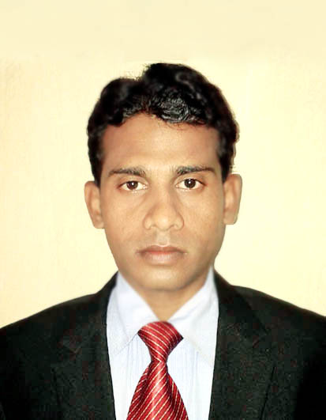
CURRICULUM-VITAE

MD.TANWEER AHMAD
E-mail- tanweer.smu@gmail.com
Contact no: +91 9835392759,8409373260
At - Mahuda Basti, PO+PS - Mahuda
Dist - Dhanbad, Jharkhand (828305), INDIA

Career objective
To join a growing organization that offers challenges & the opportunity to grow with the company, Where Goals & objectives are clearly established & tools to reach such goals are provided.

Educational Qualification:

- Completed MBA (Marketing), from Sikkim Manipal University, Gangtok 2009-2011.

- B.Com (Accounts) Hons, from VINOBA BHAVE UNIVERSITY, Hazaribagh, Jharkhand in 2006 with 1stClass.

- I.Com from JHARKHAND INTERMEDIATE EDUCATION CONCIL , Ranchi in 2003 with 1st Division.

- Matriculation from JHARKHAND SECONDARY EXAMINATION BORD, Ranchi in 2001 with 2nd Division.

Work experience
:- MOTO FORCE LUBRICANT(sales promoters) in dhanbad
:- TATA TELESERVICES (sales promoter) in Dhanbad
:- As a Cashier in S.B.I ( Customer Service Point) Electro Steel Road, Bokaro from 15.08.2011 to 15.02.2013
Summer Training Project
Project Title :- The Role of influencer in the buying process of cement.
Organization Name :- ACC LTD. .
Location :- Sindri, Area Office Dhanbad (Jharkhand).
Main objective of the Project :- To Gain Experience and knowledge in marketing Strategy.
Industrial Visit :- Lumbini Beverage Pvt. Ltd. Pepsico (Hajipur) PATNA.
Skill(s) & Expertise
- A Self -learning latest trends in telecom Industry.
- Flexible to adopt in any environment.
- Comprehensive problem solving abilities.
- Team facilitator.
- Set planning to achieve new goals

Computer Knowledge
- Tally 7.2, (vat, Service Tax, TDS) from tally Academy, Dhanbad.

- Proficient with MS Office.

Personal Contact

Fathers Name :- Md. Dildar Hussain Ansari

Date of Birth : - 11th Dec, 1986

Sex :- Male

Marital status :- Married

Language Known : - English, Hindi & Urdu

Mob No :- +91 9835392759, +91 8409373260

Nationality : - Indian
Permanent address :- House No.77
Vill: Mahuda Basti, P.O+P.S-Mahuda.
Dist: Dhanbad, Jharkhand.
Pin: 828305

Date: .. Signature

Place: (Md.Tanweer Ahmad)

