MD.MONAZEER HASAN  Email Id: Mdmonazir54@gmail.com  Contact No.: +91 7352983550,7903167459. | PRESENT ADDRESS:  AT - MANDU P.O-MANDU  Dist:- Ramgarh,  (Jharkhand) Pin-825316. | 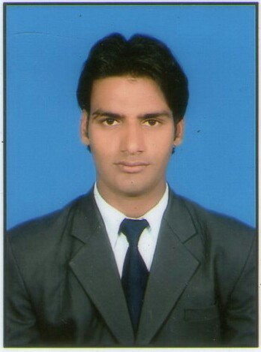

With the Intention of implementing my knowledge in a competitive environment that will give benefits to organization and also help in my steady professional growth.

- MBA with dual specialization (1.MARKETING, 2.BANKING FINANCE) from ANNAMALAI UNIVERSITY, Chennai, Tamil Nadu.

- Bachelor Degree in Commerce from Ananda Collage, Vinoba Bhave University, Hazaribag in the Year 2008 to 2011 with 1st Division.

- Intermediate in Commerce from Ananda Collage, Hazaribag
Jharkhand Academic Council,Ranchi in the year 2006 to 2008 with 2nd Division.

- Matriculation from S.S.High School, Jharkhand academic council
In the year 2005with 2nd Division.

Experience

Experience
- Four Year Teaching Experience in private school, Hazaribag,
- One year Data Entry Operator in VISHAL POWER ROLL zullu park Hazaribag,
- One year experience in INDIA INFOLINE FINANCE LTD as Take over Manager in Hazaribag.
- Three Year Post on ACCOUNTANT in Srijan Foundation, Hazaribag.
(Tally ERP Entry, BRS, Field Visit, Cash book Maintain)
Other Qualification

- Advance Diploma in Computer Application (A.D.C.A),
- Tally & Erp9.

Competencies & Attributes
- Enthusiastic and self-motivated
- Sound Communication skills (written, oral and listening)
- Can work effectively with diverse groups of people

Language

- English
- Hindi
- Urdu
Hobbies & Interest

- Playing games,
- Watching movie.
0
Personal Details

- Father’s Name : Md. Rafique Alam
- Gender : Male
- Date of Birth : 15 Dec -1989
- Address : Vill+P.O- Mandu, Dist- Ramgarh (Jharkhand)
Pin code- 825316.
Internship

- Organization : BANK MAHARASHTRA
- Location : HAZARIBAG(JHARKHAND)
- Duration : 25nd JUNE 2012 to 31st AUGUST.
- Designation : MARKETING SURVE AND FINANCIAL REPORT
- Country : INDIA

Declaration
I consider myself familiar with MARKETING AND FINANCE aspects. I am also confident of my ability to work in a team. I hereby declare that the information furnished above is true to the best of my knowledge.

Place: Hazaribag Signature:
Md. Monazeer Hasan

