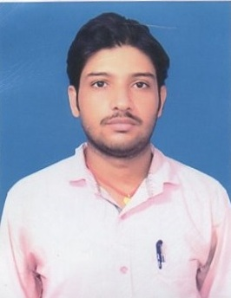
RESUME

RAJ KAMAL MISHRA
S/O –PREM SHANKAR MISHRA
MOTHER NAME – KUSUM DEVI
VILL-SANOUR,P.O-SANOUR, P.S-BASANTRAY
DIST-GODDA,PIN-814155,JHARKHAND Mob:-7544056107

ACADEMIC QUALIFICATION: Email Id:-mishrarajkamal562@gmail.com
Exam/Degree | Year | Subject | University/ Bord | Div
MATRIC | 2010 | ALL SUBJECT | JAC RANCHI | 50.80% 2nd DIV
I.COM | 2012 | COMMERCE | BSEB PATNA | 48.60% 2nd DIV
B.COM | 2016 | ACCOUNTS (H) | TMBU BHAGALPUR | 67.25% 1st CLASS
M.COM | 2016-2018 | ACCOUNTS | TMBU BHAGALPUR | Pursuing
Extra Qualification : TALLY

Career Objective : To work with full dedication and honesty to achieve the goal
For development of organization and self
PERSONAL PROFILE
Nationality : Indian
D.O.B : 05/04/1995
Gender : Male
Status : Unmarried
Language Know : Hindi, English
DECLARATION:
I hereby declare that above information is correct to the best of my knowledge and belief.

Place: ……………..
Date: ……………..… Signature

