PRAMOD KUMAR JHA
For work samples
please visit :
www.pramodjha.epizy.com
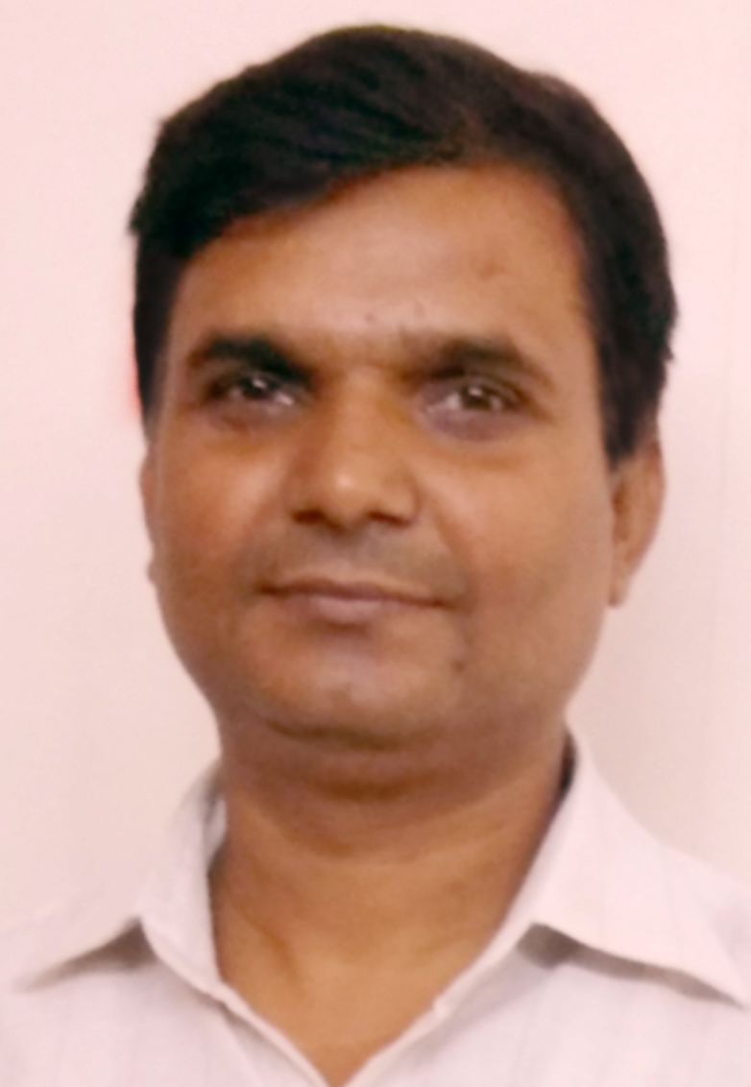
CONTACT: +91 9810653315; +91 9910839928;
E MAIL- ID : pramod.dilip@gmail.com
Website : www.pramodjha.epizy.com
ADDRESS: 408, Gali No. 8, Block - A, Jaitpur Extn.-II,
Badarpur, New Delhi – 110044

GRAPHIC DESIGNER/Web Developer
Seeking challenging assignments in an organization of repute which provides me avenues for professional learning and makes good use of my technical skills and encourages individual growth

PROFILE
- Highly creative design professional with widespread experience of Graphic Designing and Web Developing, poised to contribute experience, innovative graphic artistry, evolving new style and methodology to produce highest caliber designs, utilizing most current technologies, and collaborative brainstorming strategies.
- Highly innovative professional committed to pursuing a long-term career in Graphic Designing plus Web Developing with hands on exposure in Print and Web Media.
- Expertise in Page Layout Designs, Design for Magazines, Photographs Retouching & Logo designing Mathematical equation and Digitizing. Web Designing and Developing with screen friendly layout.
- Strong knowledge of Designing Software like InDesign, Photoshop, CorelDraw, Illustrator, PageMaker, MS Office, HTML5, CSS3, JavaScript, jQuery, PHP, XML, MySqL, Laravel 5.3, Wordpress, Bootstrap, Dreamweaver, Sublime Text 3, Flash and many more.
- Outstanding layout talents and meticulous attention to detail having successfully handled print and electronic layout design, designing advertisement material, hoarding & logos.
- Results driven professional with proven ability in design and production of artwork for wide variety of printed materials viz. posters, newsletters, dockets, leaflets, worksheets, brochures, press advertisements, and booklets.

Current Achievements
Graphic Designing | Coffee Table Book for Ministry for External Affairs, Released by Hon’ble PM Sh. Narendra Modi at Pravashi Bhartiya Diwas, Bengaluru
Website Developing | mountaincities.org launched at UrbanFutures2017 (Congress on Himalayan Cities, organised by CUGS and supported by Govt. of India) at IIC, New Delhi  shefaprojects.com for a MNC Company

OPERATIONAL EXPERTISE
≈ Visualization / Conceptualization ≈ Advertisements ≈ Packaging Management ≈ Designing of Promotions
≈ Coordination / Liaison ≈ Target / Deadline Oriented ≈ Project Management ≈ Concept Analysis ≈

TECHNICAL SKILLS
Designing Software | Indesign, Photoshop, CorelDraw, Illustrator, PageMaker, MS Office
Website Designing Programs | HTML5, CSS3, JavaScript, jQuery, PHP, XML, MySqL, Laravel 5.3, Wordpress, Bootstrap, Dreamweaver, Sublime Text 3, Flash

PROFESSIONAL EXPERIENCE
- Spearheaded efforts across developing and ideating various concepts and designs, visualizing, planning & designing layouts, which are interactive & expressive, using well-honed creative abilities.
- Responsible for exploring new formats, concepts, colors and providing typographic solutions to appeal specific audiences.
- Vitally contributed in creating the designs as per the customer request and assisted efforts for Visualisers, Art directors, Copywriters and Designers by providing new and innovative concepts for effective design.
- Attain extensive experience in using of computers and its software including Photoshop, CorelDraw, Illustrator, PageMaker and InDesign for layout.
- Handles all the activities ranging from visualization to final artwork to design Brochure and Catalogue for HCL.

CREATIVE EDGE, CHATTARPUR, NEW DELHI
Graphic Designing

- Designing of Biotech News (by Department of Biotechnology, Ministry of Science, Govt. of India), Connect (a Scientific Magazine), Performance Report, Annual Report and Endowment Document for Indo-US Science and Technology Forum, Ensemble (Bimonthly Newsletter) and Annual Report for Indo-French Centre for the Promotion of Advanced Research), Urban Nature, News Letter for Center for Urban Green Spaces, BIRAC i3 for BIRAC, TDB Newsletter and Annual Report (Published by Technology Development Board), NCF Newsletter, SERB Annual Report and many more.

Web Designing
- Designing/Developing and Maintenance of : www.shefaprojects.com; www.aravalifoundation.in; www.dnaclubs.org; www.worldwithoutwalls.in; www.cugs.in; www.biotechnews.co.in; www.urbanfutures.in; www.mountaincities.org; ssgraphics.co.nf

MIRIK HEALTH FOODS PVT LTD., CONNAUGHT PLACE, DELHI
Graphic Designer / Web Developer

- Managing designing work for advertising ads, Box, Profile etc for news paper, magazine to promote company and its product as well as updating webpage of Mirik Health Foods Pvt. Ltd.
- Designing of ads includes the scanning, Insertion & final touching of images, designs and Page Layout for news paper and magazine.
- Developing Brochure, Catalogue, Banner, Poster, Cards and various creative ideas to product promoters.
- Spearheading efforts across Creative Art Work; visualizing, planning & designing layouts which are interactive & expressive, using well-honed creative abilities.
- Handle all the activities ranging from visualization to final artwork.
- Job profile entails visualizing, planning & designing layouts which are interactive & expressive, using well-honed creative abilities.
- Actively involve in developing and ideating various concepts and designs.
- Coordinate and liaise with the fellow designers and provide new and innovative concepts for effective design.
- Effectively interacting with the clients and involved in creative sessions thereby presented creative ideas.
- Display credibility in designing and editing photographs using computer Software.

SAILOR TODAY
Graphic Designer
- Participated in regular department training with the collaborative team and supportive staff for complete layout of magazine
- Designing of Sailor Today and advertisement of shipping company to be published in the magazine
- Tasked with Planning, Organizing, and Executing orders to meet the final goal.
- Maintenance of its website : http://www.sailortoday.in

ACADEMIA
DIPLOMA IN COMPUTER SCIENCE from IEC
CERTIFICATE IN COMPUTING from IGNOU
BACHELOR OF ARTS from BBRA University
HIGHER SECONDARY CERTIFICATION from Ram Dayalu Singh College
SENIOR SECONDARY CERTIFICATION from Kailashpati Uchcha Vidyalaya
Personal Information
Hobbies : Developing new skills, Listening Music, Team making
Language : English, Hindi
Current Salary : Rs 3,60,000 PA

