 | RESUME
20/12/2018 | RAVI SEKHAR KALLA
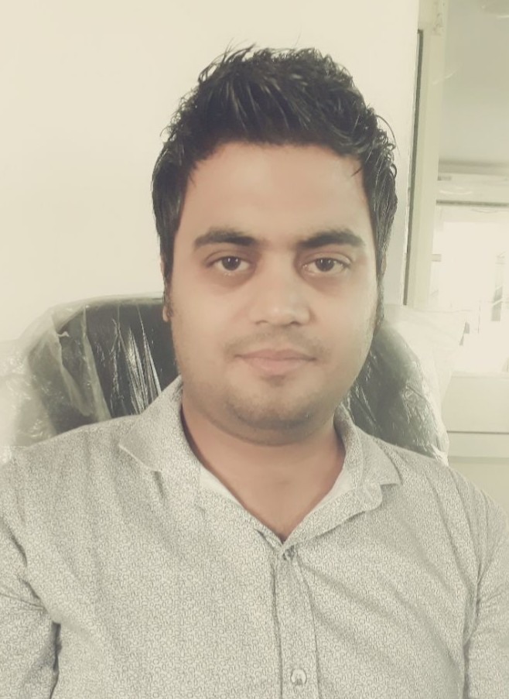 | Kallon KI Gali,Chhothani ojha Chowke,Bikaner(Rajasthan)  +91-9252343536(Rajasthan),  +91-9079317154(Rajasthan).  Email:- ravikalla.cse@gmail.com  My Confidence is the Hall of my Victory, so I always concentrate and work hard to build up confidence in me to achieve success in every sphere of life.

OBJECTIVE
To become a good employee & to build career with leading corporate of Hi-Tech environment with committed & dedicated people, which will help me to explore myself fully & realize my potential Willing to work as a key player in challenging & creative environment.

EDUCATION
- Bachelor of Technology (CSE) Rajasthan Technical University, KOTA.
- Higher Secondary RBSE Board, BSER, AJMER, RAJASTHAN
- Senior Secondary RBSE Board, BSER, AJMER, RAJASTHAN

EXPERIENCE (Oct 2018 – Till Now)
- Center manager (Business/CSR project) | Edu Bridge Learning pvt.ltd.
- Quality Control, Training, Placement, Mobilization.
- Working Experience of Project Coordinator, Revenue Generate and Managing Team.

ROLES and Responsibility:-
- Centre Quality Check
- Achieve Business Goal
- Achieve Target According to Clint Need.
- Taking Placement Session
- Monitoring all Placement Activities.
- Knowledge of issues pertaining to area of assignment.
- Knowledge of budgeting and accounting principles.
- Knowledge of organizational practices.
- Knowledge of supervisory practices and principles.
- Skill in budget preparation and forecasting.
- Skill in both verbal and written communication.
- Skill in coordinating and prioritizing work and activities of self and others

EXPERIENCE (Oct 2017 – Aug2018)
- Assistant manager (Training & Quality Control) | ICA EDU SKILLS PVT LTD
- Quality Control, Training, SDMS, ERP, Skill Attendance Portal, Placement.
- Working Experience of Project Coordinator and Managing Team.

ROLES and Responsibility:-
- Centre Quality Check
- Achieve Business Goal
- Handling all Related Portal (SDMS portal, ERP portal, Skill Attendance Portal).
- Taking Placement Session and Preparing Session plan according to Guideline.
- Monitoring all Placement Activities.
- Knowledge of issues pertaining to area of assignment.
- Knowledge of budgeting and accounting principles.
- Knowledge of organizational practices.
- Knowledge of supervisory practices and principles.
- Skill in budget preparation and forecasting.
- Skill in both verbal and written communication.
- Skill in coordinating and prioritizing work and activities of self and others

EXPERIENCE (Jan 2014 – Sept.2017)
- QA Engineer| Auricle Technology
- Handling Bugs Report, Test Case Report, Performing Application on Different Platform.
- Manual Testing in both Mobile and Web Application

ROLES and Responsibility:-
- To read all the documents and understand what needs to be tested.
- Based on the information procured in the above step decide how it is to be tested.
- Inform the test lead about what all resources will be required for software testing.
- Develop test cases and prioritize testing activities.
- Execute all the test case and report defects, define severity and priority for each defect.
- Carry out regression testing every time when changes are made to the code to fix defects.
- Defining the testing activities for subordinates – testers or test engineers.
- All responsibilities of test planning.
- To check if the team has all the necessary resources to execute the testing activities.
- To check if testing is going hand in hand with the software development in all phases.
- Prepare the status report of testing activities.
- Required Interactions with customers.
- Updating project manager regularly about the progress of testing activities.

EXPERIENCE (Aug 2011 – Dec 2013)
- Centre Manager| Dream world Institute

ROLES and Responsibility:-
- Manages all operational activities of the training center including staffing, facilities, and coordination with vendors and suppliers.
- Responsible for supervising trainers and instructors.
- Counseling & interpersonal skills (ability to understand people’s needs).
- Excellent communication skills & time management skills
- Financial management – keeping budgets, managing expenses
- Managing people

SKILLS
- Technical Skills: ERP Software, SDMS, CRM, Quality Assurance, Quality Management, Manual Testing.
- Language: C++.
- Database: DBMS.

Summary of Work Experience:
- Edu Bridge India Pvt.Ltd.
Dates of Employment: Oct.2018-Till Date.

- ICA EDU SKILLS PVT LTD
Dates of Employment: Oct.2017-Aug.2018.

- Auricle Technology
Dates of Employment: Jan. 2014-Sept.2017.

- Dream World Institute of Computer and Banking
Dates of Employment: Aug.2011-Dec 2013.

Professional Experience:
- Project #1 : PMKK (Government Project, Skill India).

- Project #2 : IJRITCC
Software Platform : iOS, android, web application.

- Project #3 : Big Files Emailer
S/W platform : Android 2.2 and up

- Project#4 : Hindi Siksha
S/w Platform : web application

- Project #5 : World Journal Alerts
S/w Platform : iOS, android, web application

- Project#6 : Animated video
S/w Platform : Android, Web Application

PERSONAL DETAIL
Name : Ravi Sekhar Kalla
Father Name : Rajendra Kumar Kalla
Father Occupation : Government Employee
Mother Name : Usha Kalla
DOB : 27/08/1989
Marital Status : Married
Language Name : Hindi,English.

